Celebrating Helen’s birthday march, 8.

René Berends, 2024
On March 8, we will celebrate Helen Parkhurst's birthday. She would have lived to be 138 years old! 138 years isn't exactly a memorable number. We have to wait another 12 years for that, but it is an interesting moment, because all over the world around, there is a commemoration of the 100th anniversary of Dalton education.
In this article, I will briefly pay attention to the youth of Parkhurst and remember all those festivities around 100 years of Dalton.
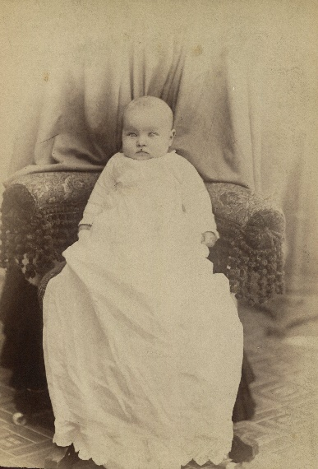 | 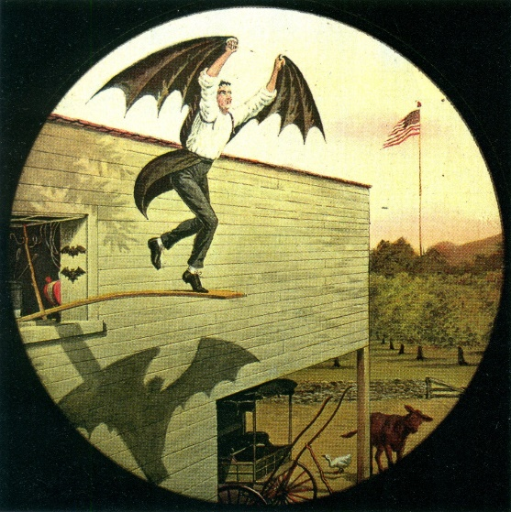
Helen Parkhurst, 1886 | Darius Green Flying Machine  magic lantern slide
Darius Green Flying Machine
Helen Parkhurst was born in 1886 in Durand (Wisc.) in the United States of America. Helen's arrival in the Parkhurst family is preceded by a girl. However, the baby dies at birth. It doesn't take much empathy to understand that both parents are relieved when Helen, a year later, with the help of the local midwife, Mrs. H. Weifer, born healthy (Pinkowski, 1999, p.16).
Helen's parents are James and Ida Parkhurst. Her father trades cattle for the major slaughterhouses in Chicago and he and his wife run Hotel Parkhurst on the main street of Durand. After Helen, two boys were born in the family, William and Alden.
During busy times, grandmother Mary Underwood helps out at the hotel and the family. She has a good relationship with her granddaughter, gives Helen confidence and later also supports her financially during the start of her teaching career. Helen also receives support from two of her grandmother Mary's brothers, 'uncle' William and 'uncle' Fred. These men are directors of a number of railway companies in the country and have access to people who will advise Parkhurst in planning her further career.
Helen is an intelligent, curious, precocious and enterprising child and is given the freedom and confidence by her parents to explore the world. At the age of five, she could read so well that she was asked to demonstrate her skills to the teachers at the Pepin County Teacher's Institute. These teachers from rural schools in the region periodically meet for meetings and courses in the hotel taproom and in the Court House across the street. Helen will then make an annual appearance during the summer courses.
At home, the family breathes culture and freedom. People read and discuss, make music, draw and paint. Helen draws on the walls of her bedroom and when they are full, she can simply move to another room where she can continue drawing in peace.
In her youth, neighbors called the precocious Helen “Darius Green's Flying Machine,” after a poem written by John Townsend Trowbridge around 1870 (Luke n.d., Champion, p. 8). She is energetic, sometimes restless. In her biography of Montessori, Rita Kramer describes Parkhurst as a bubbly young woman, with a quick smile, who seemed to always be talking (Kramer, 1976, p. 214). Parkhurst's friend, Dorothy Luke, uses similar words: “I saw her as a dynamo and rainbow – a dauntless, driving ambition to demonstrate the truth of her insights linked to a child-like joy in the child's world” (Luke n.d., Pursuit: introduction, p. 1 and 2). Luke also points out Parkhurst's pioneering blood: “Like a true pioneer, Parkhurst shouldered her way past every obstacle to her goal.” A former student of the New York Dalton School, Marian Seldes, writes: “Her presence in the building was so strong” (Seldes, 1973, p. 1).
100 years of Dalton
After Parkhurst resigned as Montessori's representative in America, she started her own school in 1919 in a former Montessori school. That school will evolve into the New York Dalton School.
This school is the first Dalton school in the world who celebrated its centenary. That happened in 2019, five years ago.
The Dalton Plan was soon after introduced at various schools all over the world: from Poland to Australia, from England to Japan, from Spain to China and from de U.S.S.R. to the Netherlands.
Most of those schools are no longer Dalton schools, but there are a number that have now also celebrated their centenary, such as Ascham in Australia. There they celebrated one hundred years of Dalton in 2022.
In the Netherlands, Dalton education was first experimented with in 1924. This was initially done by individual teachers in their own classrooms. A year later, the first integrated Dalton schools were established. One of those schools still exists. That's Dalton The Hague. They will celebrate their centenary as a Dalton school in 2025.
The oldest existing Dalton school for primary education in the Netherlands became Dalton School in 1930. It is the Dalton school Pieterskerkhof in Utrecht. It is the school where the president of Dalton International, Roel Röhner, was director for many years. It will take six years before 100 years of Dalton can be celebrated at that school. But there is certainly also something to celebrate this year. The school was founded in 1824 and that is exactly 200 years ago.
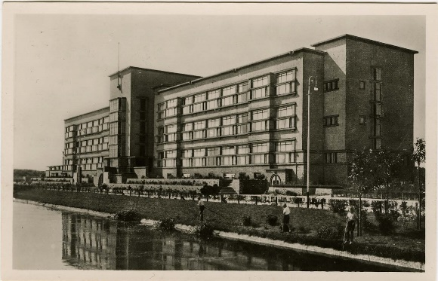 | 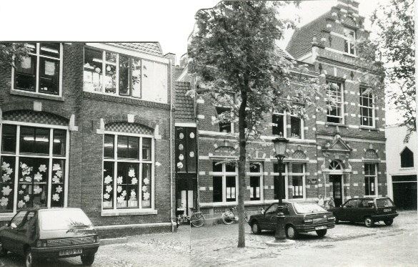
Dalton Den Haag | Dalton school Pieterskerkhof Utrecht

