Doing the best in the best way
Developing a vision on Dalton education
René Berends, Hilde-Marie van Slochteren, Vera Otten-Binnerts, 2022
Introduction
The Dalton Plan is an educational concept with attention that pays attention to didactics to didactics and organization, accompanied by a pedagogical dimension. It is about 'doing Dalton' and about 'being Dalton'. That is what Parkhurst meant with her expression that ‘Dalton is a way of life' (Parkhurst, 1922).
Parkhurst was practical and pragmatic in everything. She has left no publications with deep philosophical considerations. It was all about “a simple reconstruction of school procedure under which the pupils would enjoy more freedom as well as an environment better adapted to the different sections of their study” (Parkhurst, 1922). She felt that there was a lot wrong with the education of her time she felt there was something wrong with the contemporary education: “It is restrictive, not educative… It is fatal to the idea of a school as a vital social unit” (Parkhurst, 1922). She therefore wanted to 'revitalize' the education of her time and saw that great gains could already be reached by applying the principles of 'freedom' and 'interaction of group life'.
Viewed in this way, Parkhurst's Dalton Plan is indeed primarily a didactical and organizational concept. But Parkhurst said that there is more to be done, both regarding the educational content and regarding the 'pedagogical revitalization' of education.
Critics mainly perceive the Dalton Plan through the prism of several didactic and organizational measures with which the rigid 'lockstep teaching' can be renewed. And it is true that Parkhurst’s primary priority is not curriculum innovation. In 1922 she writes: “Any curriculum can do with the plan.” But Parkhurst thinks there are also needs to do something in that area: “It would be folly to deny that all children enjoy a truly fine mental meal more than a poor one. Better curriculum food is already in sight, but, at present, conditions are not right for the new curriculum. The ground must be prepared, and it is for this reason alone that I have directed my study to school conditions rather than to school curricula” (Parkhurst, 1926).
It seems a form of realism. You cannot change everything at once. Parkhurst started with a simple reconstruction of school procedure under which the pupils would enjoy more freedom as well as an environment better adapted to the different sections of their study. But ten years after she published her book Education on the Dalton Plan, her ideas are different. In the period 1932-1940, the New York Dalton School took part in a major research project among twenty-eight prominent progressive schools in America (The Eight Years Study). In the context of that research, in which the curriculum of the school has been aligned with that of prominent universities in the country, Parkhurst is fully committed to curriculum innovation. In this period Parkhurst is implementing a curriculum for Social Science at school, as a kind of 'citizenship education'.
Parkhurst also mentioned ideas for the pedagogical revitalization she desired. As early as page 4 of Education on the Dalton Plan, citing Conklin, she provides a strong (pedagogical) critique on American education and how social institutions such as churches contribute to the education of children: “Any education is bad which leads to the formation of habits of idleness, carelessness, failure, instead of industry, thoroughness, and success. Any religion or social institution is bad which leads to habits of pious make-believe, insincerity, slavish regard for authority and disregard for evidence, instead of habits of sincerity, open-mindedness, and independence. These are the beacon lights towards which education should tend” (Parkhurst, 1922).
She sees that children in schools and churches develop such habits as laziness, carelessness, failure, pious appearances, insincerity, servile esteem for authority and disregard for evidence, instead of zest for work, thoroughness, wanting to be successful, sincerity, open-mindedness, and independence. It might be only perceived as a formal accusation of the pedagogy of that time.
The Dalton Plan is therefore primarily a concept with the aim of 'revitalizing' of education in a didactical and organizational way. But in Parkhurst’s publications you can also find building blocks for broader pedagogical action, based on a value orientation about doing ‘the right thing'.
Parkhurst is concerned with educating children to become fearless human beings. They are cultural participants, but also cultural innovators, who develop themselves as individuals, but who also contribute constructively to society.
Working from a Dalton vision
A Dalton school is a concept school, where all those involved are focused on putting the Dalton concept into practice. Everyone tries to be 'consciously competent', that is to say: everyone tries to be aware of how to do 'the good' as well as possible.
To determine what is 'the right thing' to do, a value orientation is necessary. It is about what you consider worth striving for at school in the upbringing and education of children.
People’s opinions may vary in that discussion. An educational pedagogical vision is therefore not something objective. Pedagogy is a value-oriented science. But once a vision has been clearly defined and formulated, you can then consult educational sciences to investigate what needs to be done from a didactical and organizational point of view to realize that vision effectively and efficiently. This means that once it has been determined what 'the good' is to do, it must then be examined how that good can be done in an effective and efficient way.
In this article, a model is presented to investigate your own Dalton vision. The components of this model are discussed, after which the principles of Parkhurst's Dalton Plan are explored with that model.
Since individual’s educational visions may vary, it is crucial for the development of your own Dalton vision to conduct a dialogue with each other.
The importance of having your own vision
Before we discuss the building blocks with which you can develop and articulate your own Dalton vision, it is important to consider the importance of having an own educational pedagogical vision. There are quite a few people and institutions who interfere with 'our' profession, people who give their opinion about what should be done in education. That is their right, but it should not lead to teachers being side-lined, having nothing more to say about the content of their own work at schools.
In this regard, Biesta (2020) speaks of false prophets who circle around education and who promise that if you follow their recipe, education will become 'perfect' (more measurement, more evidence, more neuroscience, more 'visible learning,' more PISA, more direct instruction, more method, etc.).
These kinds of promises all contain a piece of the truth and often sound attractive, especially from a short-term perspective, but those who study the history of education know that such promises are ultimately only partly fulfilled. The pressure from society may become enormous that teachers limit themselves to slavishly following what they are instructed and taught. It is difficult for teachers and for school teams to keep the right 'middle' with some rest and distance and not to get out of balance. A good possibility for this is to hold on to one's own educational pedagogical vision and to enter a dialogue from there.
In a critical essay on education, Martens, Biesta, Stevens and Valk state: “Education does not exist” (Martens et al., 2020). They clarify this position as follows: “It is not laid out on a shelf, it is not listed in an agenda or contained in a curriculum. Education is not a controlled production line in which certain inputs lead to certain outputs. A school is not a cookie factory, the metaphor has been made more than once. Education is constantly being remade, in the interaction between subjects, independent beings, in varying contexts. How this interaction leads to education is not predetermined. In this view, education is not: a series of interventions that have a certain effect on students. That is not how it "works". Education is people's work. What works for one teacher will not work for another. What is appropriate at one time is not at another. This is the dynamics of education. Even more than the craft, you might call this the artistry, tact, or virtuosity of the teacher; you can still know so much or have so many skills… whether you can get a good education with this group on this Monday morning is always at stake. Education is therefore a wonderful, but risky business at its core.”
That is precisely why teachers should stop seeing themselves as a direct object and wait like a turtle on its back with its paws tucked in. Gradually, teachers have been increasingly deprived of their profession, their profession has fallen in prestige and teachers have become conduit for what others think and have developed.
However, scientists, consultants, influencers, educators, journalists, method and curriculum developers, policy makers and managers are all coaches standing on the side-lines shouting what needs to be done on the playing field. They have every right to do so, of course, but teachers should act as 'a fearless teacher'. Consider their input as well-intentioned advice that you gratefully add to your backpack full of existing knowledge, insights, and skills, but you do keep control. Teachers need to realize that only they know the real playing field: the children, the time, the situation, and circumstances under which work, and learning takes place.
That is why it is essential to chart your own course and to demand professional space to tailor education to the children and the circumstances (Kelchtermans, 2013). Teachers must think more autonomously, show their professionalism, bring themselves into play, hold up a mirror to themselves, so that they too can hold up a mirror to the world. If they do not, it quickly leads to conformism: education like marking off tasks on job sheets. Teachers need to keep reflecting on why they do things the way they do, keep tuning in, constantly ask questions, be open to the new and the different and thus to recreate the teaching repeatedly. And that is only possible if they set their own course based on their own educational pedagogical vision.
Working from such a vision as a teacher, you are not just a follower. Putting 'fearless teachers' on the agenda and indicating that there is a need to talk, indicate that things are happening that are unacceptable. In this way you can anticipate external influences together in a team. Then you keep your course. Then you are critical of the next new hype. And if the counter current is too strong and active resistance is pointless, then you do not force, but you bend like ears in the wind and you may even choose to 'actively do not' (Linsen, Berends, 2019).
Framework for the development of a (Dalton) vision
Whether you like it or not, no one is neutral in how he views what should be done in education and in the upbringing of children. The discussion among teachers, but also among researchers, journalists, educators and administrators about the importance, functions, intentions, and desired results of education is always value related. And from their own perspectives, they also see various problems and challenges for educational practice.
Teachers and school teams should be partners in those discussions. This prevents people from talking about us without us. But if teachers want more control over their own profession – and that is necessary because they have a better understanding of how education can be geared to the children –, then their own vision is essential.
This article discusses three tools that can be used to arrive at such a personal vision or professional identity: (1) Sinek's Golden Circle, (2) Van den Akker's Curricular Spider Web and: ( 3) the Vision Flower of Berends, van Slochteren and Otten-Binnerts.
They are models that visualize that you can plan your educational practice based on an explicit vision. Please note: these models are used as scaffolding tools. And as the quote attributed to George Box says: “All models are wrong, but some are useful” (Box, 1976). Models are simplifications of reality, sometimes even caricatures of it. The intention is to use them as as a tool, but if they unexpectedly hinder you in developing your own vision on education, you should not use them.

De Golden Circle
Sinek (2009) investigated why companies and leaders are successful. He showed that a lot of companies have no idea why their customers are their customers. He developed a thinking model – the Golden Circle – with which he visualized how successful companies and leaders have developed a way of thinking, acting, and communicating that runs from the inside out. Education is of course not a commercial business, but here too it is important to start from the 'why', from the feeling and inspiration, and then to think about how that vision can be realized ('how') and what to do next in practice ('what').
The 'inside out' approach does carry a risk. Teachers are practical and discussions about their own 'why' can degenerate into fancy words that quickly turn out to be 'empty' generalities. That is why a combination can be used as well with an 'outside in' approach. When team members collect examples of education that make them 'happy' and together analyse where that happiness comes from, you arrive at what moves you in your work. And that essence is in line with what you find important in education and upbringing, with why you have chosen this profession. Those essences are therefore food for your vision.
Thinking about the 'why', about the goals in teaching and raising children, is about central values ​​and the identity you stand for, who and what you are and want to be, but also how you are and how you want to be. It is about your core values, which provide the breeding ground and the accountability framework for your concrete actions. That 'why' is about beliefs, principles, your vision of good and evil, about what you find desirable and undesirable, the values, ​​and standards in which you believe. It is about what qualities are worth pursuing for you, about values ​​such as being dependable, innovative, respectful, ethical, and honest, about giving space to children, letting them develop to their full potential, being pure and sincere, energetic, refreshing, practical and goal oriented. It is about the higher purpose of the school, the answer to the question: 'Why are you on earth?' It is about what you yourself and as a team see as the essence, legitimacy and destination, the primary, permanent assignment teacher has and about how you want to make a difference as a teacher and as a team: the difference you want to be recognized for, your own unique positioning.
The formulation of the 'why' then indicates how you – as a teacher or you as a school team – see the future. Where do you want to be in five or ten years? What are the ideals, what is the shared ambition? In which direction do you want to innovate, develop? And how will you be able to see in the future that you have developed in the desired direction?
Based on this, you can think about the 'how' and the 'what', you can analyse the current situation, make a concrete plan, and determine a strategy for realizing concrete goals arising from your vision, so that you can prioritize can determine and know what needs to be done in order to realize the vision in an effective and efficient manner in the long term.
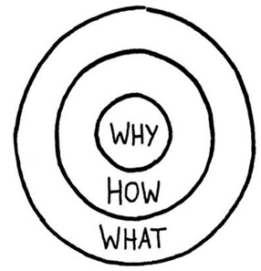 | 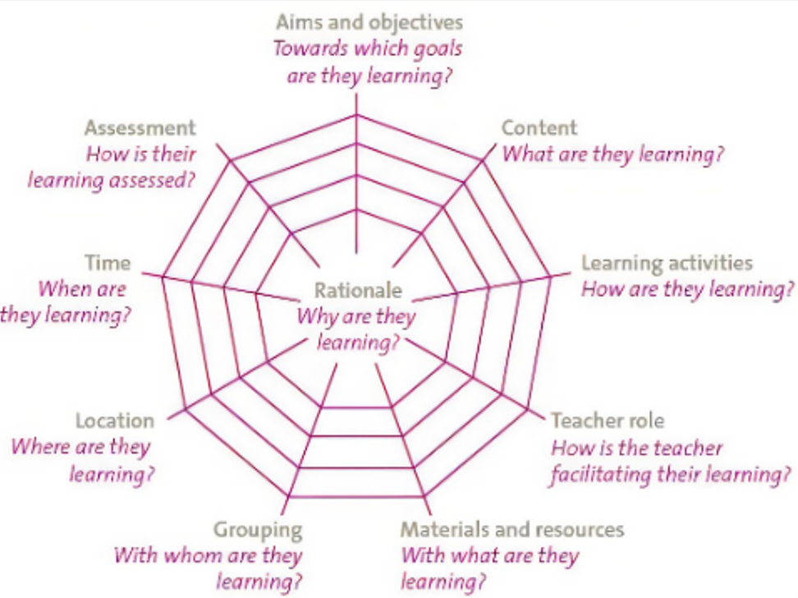 | 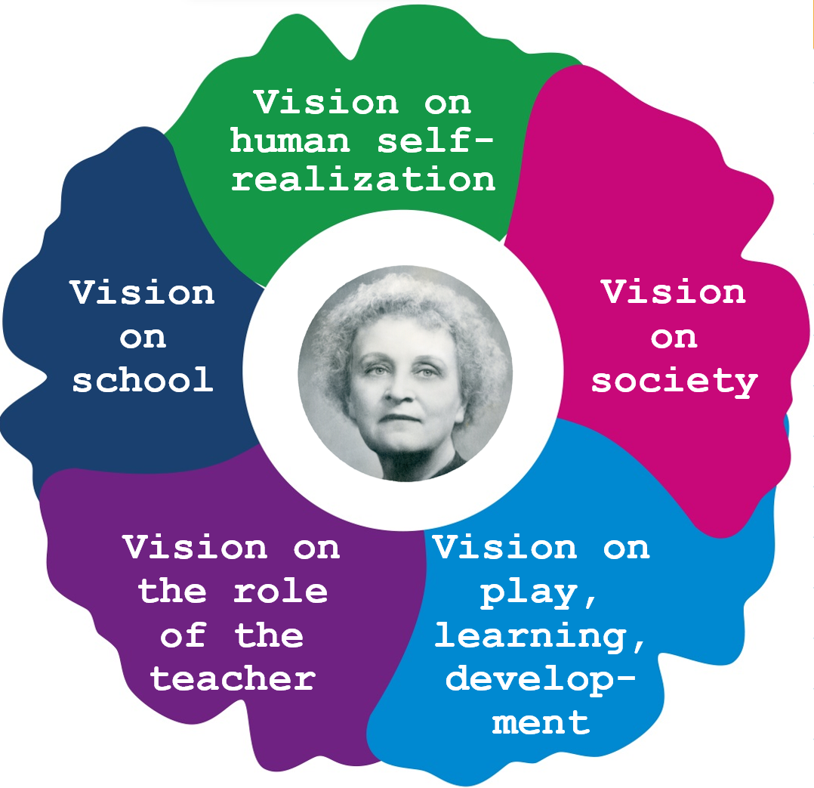
The Golden Circle  (Sinek, 2009) | Curricular Spider’s Web  (Van den Akker, 2003) | Vision Flower  (Berends, et all, 2021)
The Curricular Spider’s Web
A model that can be used to make the step from the 'why' to the 'how' and 'what' is the Curricular Spider’s Web by Van den Akker (2003). It is a general model for mapping, planning, and evaluating curricula and educational learning processes at various levels. One need to take into account that education is a continuous, cyclical process. This cyclical character is not well-expressed in the visualization of the model.
The central question is the vision, the 'why' of education. Only when “why” is clearly formulated can the following questions be considered: (1) Which learning objectives should be set? (2) Which learning contents and (3) learning activities should be chosen? (4) Which role the teacher should play? (5) How sources and materials should be used and (6) which grouping forms should be used> (7) How the learning environment should be set up? (8) How the work should be planned in time and (9) how it can be evaluated whether the goals are also be achieved in an efficient and effective manner?
The Curricular Spider’s Web can be used specially to materialize an important feature of a Dalton vision, namely, to increase the children's ownership of their own learning.
The Vision Flower
The two models discussed above have in common that they help to improve education in a planned way. We consciously use the word 'improve' here. We are not so much striving for change. It is about improving; the intention to create space, time, and opportunity to do better, to make practice better. Doing 'something' differently or working in a unique way is always possible. But for doing your work 'better', you need an idea of what 'good' is. And that requires an educational vision. The two models discussed above help to realize a vision step by step to put it into practice, but the Golden Circle and the Curricular Spider's Web do not offer tools for developing that educational and pedagogical (Dalton) vision itself. The following model has been developed for this purpose.
As has already been said, a vision as the foundation of a Dalton school requires a value orientation towards what we consider worth pursuing in (Dalton) education. If we want to give 'good' education, we must agree on what we think is 'good'. This requires answers to at least the following five questions:
- What does the pursuit of human self-realization require from education? (human vision).
This concerns the question of what is perceived as the essence of human existence and what and how personal development in education can contribute to this.

- What do developments in society require of its inhabitants (society vision) and how are children prepared to participate constructively in that society?
Education should introduce new generations into meanings. In this way knowledge, skills and attitudes, the culture and important values and norms are passed on to new generations. At the same time, society is changing, and it is necessary to teach children how they can help shape the renewal of society. An educational pedagogical vision therefore requires reflection on these social developments.

- How do we view the processes of playing, learning, forming, and developing?
If we have considered in question 1 what people need for self-realization and in question 2 about how that person can learn to contribute constructively to the world, the next question is how he can acquire the knowledge, skills, and attitudes for this. A third building block for an educational vision is therefore about your ideas about how the processes of playing, learning, forming, and developing children take place.

- What role does the teacher play in these processes of playing, learning, forming, and developing?
Building an educational vision also requires a substantiated opinion about the professionalism of the teacher. What might be expected of him or her to ensure that the learning, playing, shaping and development of children proceed as optimally as possible?

- How do we view the school as a training institute?
Finally, to build an educational pedagogical vision, it is also important to think about the school as a social education institution. Children go to school to impart knowledge, skills, and attitudes within it that they should use outside. The question must therefore be answered how we view the relationship between the school and the outside world: how we bring the world in and how we go out with the school.
Building a professional identity
From the moment students think about a career in education, they develop images about how they will shape their future professional practice. All kinds of ideas play a role in this: a mix of social and pedagogical ideals, the love for children, ideas about which practice 'fits' them as a person, their own memories of school days and examples from their environment, which they may consider worth pursuing.
You could call those images and ideas ‘the start of building a professional self-concept.’ When students then go on to study at a teacher training centre, the five questions from the Vision Flower play an increasingly prominent role. During their teacher training they become acquainted with educational pedagogical theories and scientific insights and gain positive and negative experiences during their internships. They observe the practice of their internship teachers and reflect on their first own experiences in front of the class, and they exchange experiences with fellow students and teachers. In this way, that starting professional self-concept becomes a professional identity, which is further enriched and deepened during their career.
At some point, student-teachers or teachers in schools can become acquainted with innovation concepts like the Dalton Plan. Familiarizing yourself with and reflecting on a concept such as the Dalton Plan then helps to further develop your own professional identity. It can offer new insights and thus form the basis of your own experimental educational practice.
It is the intention of this article that acquaintance with the Dalton concept supports teachers in sharpening and deepening their own professional identity. It can contribute to a unique way of looking at teaching. It can deepen your practice, making the Dalton Plan even more ‘a way of life’ for you.
In the following paragraphs, using the five questions of the Vision Flower, Parkhurst's Dalton Plan and how her ideas are realized in current Dalton education will be discussed. We will see that Parkhurst, even though she has written little, still offers a rich source of nutrition for developing your own educational vision. The following quote from Parkhurst offers an initial inspiration for this. This very compact text already contains a lot of Parkhurst's concepts, and some answers can already be found to the five questions from the vision flower.
“For service and co-operation are what we need to solve our great political and social problems to-day, and synthetic education that will provide that large and comprehensive outlook which will make these virtues a habit of thought and a practice of life. Some such total vision must be constantly in the mind of the teacher, who must ever be on the look-out for inter-relations and so stir within the minds of the children the faculty of creating channels between the different territories – channels which will fertilize the whole earth between them and give that infinite joy which comes from the consciousness of creatorship, the true function of man, the work for which he was endowed with an immortal spirit” (Parkhurst, 1922).
- Vision of human self-realization
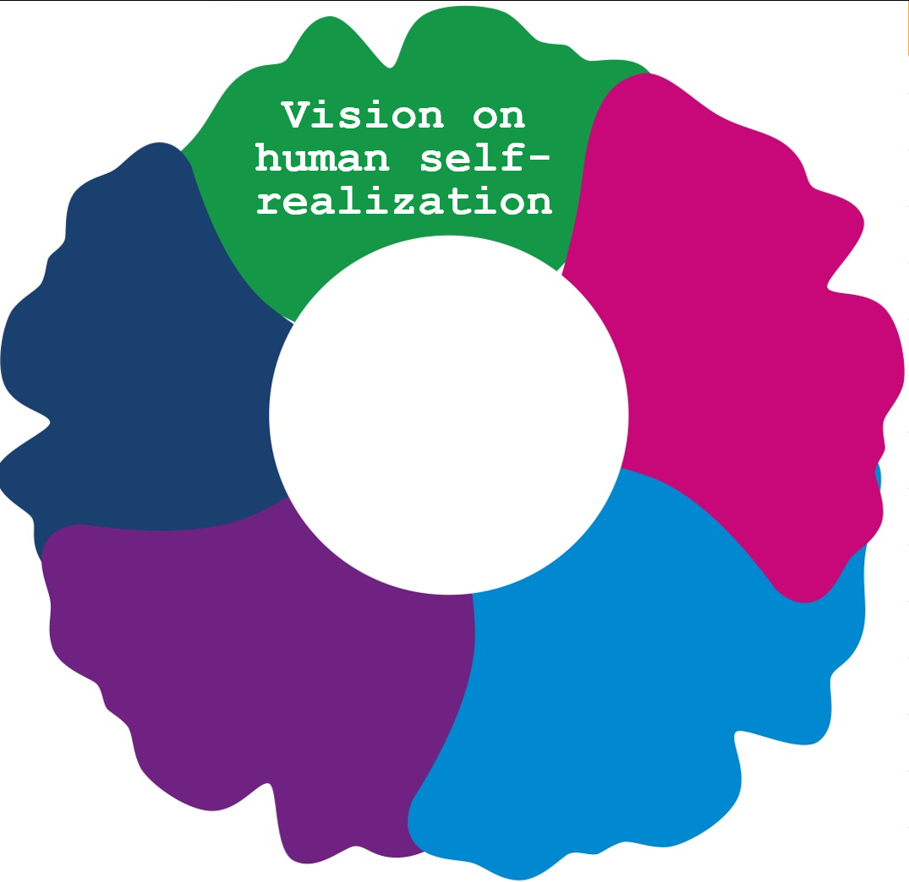 | 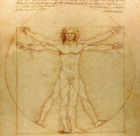  The homo quadratus  (Leonardo da Vinci, 1452-1519)
At school, knowledge, skills, and attitudes are passed on to new generations, but more is needed for children to grow up into participating citizens in a rapidly changing society, to find their own place in the world and to become happy. The school should also offer an arsenal of life techniques and give the child the opportunity to practice and gain experience with them.
Dalton education therefore wants to offer broad personalized education, where children also discover who and what they are and how they want, can or even should be. It is education where children discover where their own interests lie and where they are given the time and space to develop good talents. An educational pedagogical vision therefore offers not only an answer to the question of what knowledge and skills should be learned and how this is done, but also a position on what makes a person human and what these human needs for self-realization. For a vision on personal development, the development of an own personality and personification it is therefore necessary to think about the essence of human existence.
First, this section explores what an image of man means in the context of educational pedagogy. Based on that exploration, building blocks are provided for a personal anthropological perspective and the Dalton philosophy is considered based on the question of how these ideas can inspire you in developing and becoming aware of your own view of man.
We will start with Parkhurst.
Fuel up with inspiration from Parkhurst
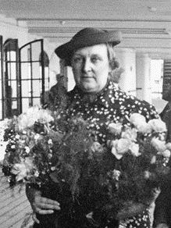
Parkhurst does not offer an explicit anthropology of its own, as many European reform pedagogues do. Nevertheless, modern Dalton education can take advice from its founder for formulating an own vision on humans. There is enough information to find in Parkhurst’s publications to find out what she believes to be the evolving human being and what he needs to achieve self-realization. For example, she says: “… and give that infinite joy which comes from the consciousness of creatorship, the true function of man, the work for which he was endowed with an immortal spirit” (Parkhurst, 1922).
Parkhurst sees his creativity as the true nature of man, and she most of all means the ability to produce practical solutions with a curious, inquisitive, and problem-solving attitude to the problems that man himself and humanity in general are faced with. She believes that children's creativity should be catered for. “The true business of the school is not to chain the pupil to preconceived ideas, but to set him free to discover his own ideas and to help him bring all his powers to bear upon the problem of learning.”
When Parkhurst speaks about her view on humanity, she uses the term 'fearless human beings'. This term is also widely used by Daltonians all over the world these days: people with guts! They aim here at the formation of broadly formed, democratic citizens, who have discovered and developed their own preferences, interests, and talents and who, partly as a result, live, work and learn independently and in freedom and behave responsibly towards themselves, their fellow man, and the world.
Parkhursts does have an idea of what the fearless human beings should do in life. From the quote on page 6 it becomes clear that she believes that they should primarily serve society. This sheds a nice light on the dilemma discussed in this section, about raising children to an ideal image or to wanting to be an independent person. Parkhurst believes that children should be raised and trained to be creative problem solvers.
Parkhurst also has an eye for what are nowadays called the 21st skills, knowledge and skills that people need in a rapidly changing world. Speaking at Caxton Hall in England, she explains what education should lead to: “We must have flexible individuals in the future, who can do their tasks which we, in our ignorance, are unable even to discern today” (Semel, 2002).
Parkhurst's Dalton Plan is therefore not only about achieving goals related to the acquisition of adequate knowledge, skills, and attitudes. It also wants to shape the child's person and personality in a good way, so that they also learn to relate to that knowledge, skills and attitudes and to themselves, to the others and to the world. It is not only about building an identity, about who or what you are, but also about the formation of a subjectivity, about how you are.
The fearless human being is a practical, pragmatic, initiative-taking and enterprising problem solver for Parkhurst. But also, a person who knows himself, who has discovered and developed his talents, interests, and passions and who uses them creatively in design. It is also about a person who lives, works, and learns independently and in freedom, who acts socially and who bears responsibility for himself, the other and his environment. From a social commitment, a fearless human being is also someone who stands for democratic values ​​and shapes active citizenship.
Parkhurst admires the pragmatism of street boys in Education on the Dalton Plan. They are quick, see-through people's intentions and display practical intelligence. Education should therefore provide such a 'practice for life' idea: education and upbringing as learning the traffic rules to cycle independently to the football club; knowledge about plants to maintain a vegetable garden yourself. But also, knowledge about diverse cultures to learn to make moral decisions.
The Anthropological Discovery
It was (in the Netherlands) in particular Langeveld (1945) who made the connection between pedagogy and anthropology. It is sometimes called Langeveld's anthropological discovery that education is part of the essential structure of anthropology (Noordam, 1970 a and b). Langeveld argues that upbringing is part of the true nature of man and that man is dependent on upbringing. In other words, being an educator and having been an educator is part of humanity. The question of the essence of being human is therefore (educational) pedagogically important.
An exploration of anthropological perspectives
The science that studies the essence of man is anthropology (anthropos = man). In it one tries to take account of human existence and investigates what makes man human and what distinguishes him. This reflection on the essence of man has led to many descriptions, in which different accents have been placed for distinct reasons. Try to find that accent when we talk about man as homo botanicus, homo correctus, homo creatura, homo digitalis, homo faber, homo humanus, homo journal, homo juridicus, homo ludens, homo natura, homo oeconomicus, homo politician or the homo rationalis. Have you already lost your way? Wouldn't it be better to have homo universalis, of which the Italian philosopher Alberti already spoke in the fifteenth century: the man who can do everything he wants?
Although this hilarious list might suggest otherwise, anthropology poses fundamental questions that are also important for upbringing and education. Because what do you think? To what extent is man a moral, rational, or cultural being? Is he creative, inquisitive, or enterprising? Is he a social or more of a personal being? Is he free? But also, responsible? And does that responsibility relate to oneself, the other, the environment or even the world?
The question of what the essence of being human is and what makes man human has historically been answered from different perspectives. This history is briefly summarized in the box.
For a long time, man has been understood in his deepest being only as a creature of God. Many creation myths tell the story that man was created by a deliberate (divine) act (Noordam, 1970 a and b). It was especially the ancient Israelites who passed on this religious anthropological perspective into the traditions of the Christian religion and Western culture.
The Ancient Greeks placed different accents. For example, Heraclitus (c. 535 to 475 BC) stated, “I search myself.” He tries to understand man from the point of view of man himself. The proverb “Know Thyself,” found in the ancient temple of Delphi, points in that direction. He also has the saying: “Life is a struggle!” Heraclitus saw struggle as an essential feature of human life.
The Sophists added to this 'Know Thyself' that man can also be understood from the culture, from what man has produced, the civilization and organizational forms in society. Metaphysical (religious) explanations of man's nature were not necessary. For the Sophists, man was the measure of all things (Noordam, 1970 a and b). This cultural perspective can still be recognized in cultural anthropology, which assumes that although man is rooted in nature, he can mainly be known from the things he creates, his culture. And because that culture develops and is passed on, man is also a learning being that can be viewed from his history. No one starts again. He builds on a past.
Socrates and Plato did maintain a metaphysical perspective. They stated that 'man' can be understood from the idea. True humanity lies in the development of the mind. Through Socrates and Plato, a moral-ethical aspect is introduced into anthropological thinking. According to them, self-discovery leads to the realization that man is of a higher origin, and it is his task to show this. In this way (self) knowledge leads to true virtue and to good (Nordam, 1970 a and b).
Only in and after the Renaissance were new elements added to anthropological thought. Thus, a more biological perspective emerges when it is discovered that humans can be seen as nothing more than a recent step in an extensive line of creatures that evolution has produced on Earth. There is also a gradual (humanistic) realization that the individual must devise solutions to problems himself, that he must personally determine positions, that he is 'free' for this, but also that he is individually and personally responsible for his choices. Rationalism then emphasizes the consciousness and thinking of man. Emerging empirical science places the emphasis on perception and romanticism then on man's intuition, fantasy, play and the urge to create. In the twentieth century, the focus shifts to the fact that man discovers his 'actual' humanity mainly in confrontation or even in collision with his fellow man (Noordam, 1970 a and b).
The two world wars and the enormous wave of democratization that the world goes through after that have added another dimension to anthropological discussions, namely to whom this characteristic and typically human actually applies. Historically, it has always been reserved for only a particular nation, system or race, class, culture or age, or gender. The democratic idea that every person has the right to his own typically human being is therefore only of a fairly recent date and certainly not yet universally accepted worldwide. This democratic impulse in anthropology therefore assumes that no individual has the right to pretend to be the best, highest, or total human being. Being human, humanity, appears in humanity as a whole and not, or even eminently not in one of its parts in particular. Uniqueness, democratic values, ​​and pluralism are therefore important anthropological principles today, which have taken shape in the Universal Human Rights.
This brief overview shows that throughout history, based on religious and ideological convictions, among other things, different accents have been placed when considering the nature of man. We will use these perspectives in the overview of fundamental questions that you can use when collecting anthropological building blocks for your educational pedagogical (Dalton) vision (appendix 1).
Der Mensch wird Mensch, wo er spielt (Schiller en Fröbel)
Existential questions about becoming a person, personal development and about the development of a personality
The question of a human image can therefore be answered from different perspectives. And if you become aware of your own perspective, this forms a starting point in the search for answers to existential (life) questions. The perspective from which you look at people and the answers you give to those questions ultimately determine how you are a 'person' as a teacher. After all, you put yourself in the game when it comes to issues such as giving meaning, offering support and security, comfort and love, offering freedom and bearing responsibility, building a sense of community, looking for like-mindedness, connectedness and togetherness, using symbolism, rites and rituals, providing spirituality, stories and culture, laying a foundation for morality (good and evil) and giving explanations about the origin and end of the universe and life.
Orientation fields
Alkema cs. (2015) identified four mutually influencing orientation fields, which can help you get a grip on your own ideas about the nature of man: who he is and who he thinks he is:
- Man, and the other (man becomes man in his encounter with the other).
- Man, and nature (man in connection with nature, as a source of energy and food: man, and nature, but also 'human nature');
- Man, and culture (man and his material and non-material creations brought about: from inventions, tools and objects to art and ideas).
- Man, and the supernature (religion, philosophy of life, thought systems and ideologies).
These four orientation fields indicate the span of how man develops as a person, how he develops his self-image, his cognition, affection and psychomotor skills, his knowledge of and view and influence on the world (his world view). Experiences on these orientation fields are expressed in form systems such as language, sound, image, and movement.
A vision on the child and child development
First the child, then the pupil (Stevens)
According to the anthropological principle of Langeveld's pedagogy, the development of an image of man includes an image of the child: the image of the developing person. Linked to this is the question what meaning being a child has for being human (Noordam, 1970 a and b). This question makes clear why pedagogy has a practical, normative anthropological dimension. If anthropology asks what 'good' is for man, pedagogy must answer the question of how to develop 'that good' in children.
Raising, forming, and teaching a child involves the formation of a person, as well as the development and formation of a personality. These are two different things and the difference between them is not always clear.
A person's personality is a dynamic and organized whole of man's thinking, feeling, will, from which they are motivated to act in different situations.
The concept of personalization requires a more extensive explanation. Biesta (2018) makes the important distinction from a pedagogical point of view between the formation of persons according to a certain image or ideal and personification as the formation of the will to be person. In the first, the learner is merely "material" to be trained and trained. In the second case, it concerns the process of becoming an independent individual. That means that the human being and also the child can do this or that, say yes or no, go with the flow or resist. He will have to decide for himself repeatedly which of those options is preferable (Biesta, 2018).
Nowadays, from an educational pedagogical point of view, the second option is highly recommended is strongly preferred. Certainly, in Western democracies we believe that children have the right to become who they (want to) be. You could say that in this endeavour pedagogy begins: to help the child to develop into a person-wanting-to-be. But that this is difficult is apparent from the long overview that can be given of pedagogical ideals that have been followed through the centuries: from the Greek ideal of Paideia (the formation and development into a fully human being: 'a healthy mind in a healthy body' ), the classical Christian ideal of education from the Middle Ages, in which children learned to live 'in imitation of Christ', to the 19th-century Bildung ideal with its emphasis on all-sided development (Berends, 2020). Children are still hindered in their striving to form themselves into independent persons in freedom. Parents, pedagogues, social institutions, even governments still have all kinds of ideal images in mind when raising children.
Biesta (2018) makes a second distinction, namely that between individuation and subjectification. He clarifies that distinction with the example of the Bildung ideal: “While Bildung is about individuation – the process by which the human organism becomes an individual, acquires identity and becomes identifiable – (…) subjectification (…) is about trying to existence as a subject of one's own actions, not as an object of powers and forces outside us... Subjectification (...) is therefore not a matter of cultivating the individual as an individual, but is aimed at bringing children and young people into relationship with their own freedom. It is about discovering the power of that freedom; to discover oneself in and in that freedom; to discover that it is their freedom and to awaken in them the desire to relate to their own freedom in a mature way. The latter means that freedom is not about 'just doing what you want to do'." Subjectification is therefore not only about letting you discover who and what you are, but also about how you are, and especially about how you are 'good'. That is, for example, the reason the Bildung ideal was criticized after the Second World War. According to the Bildungsideaal, people who were formed on all sides had led to the (self-)cultivation of the person but had not prevented the rise of National Socialism in Germany. An essential question is therefore what you are going to do with that being formed and with the freedom that has been given to you. Do you make moral choices? Do you bear responsibility? Do you think about the consequences of your actions that you have set free? Education should stimulate the desire to want to be in the world in a mature way. Using an adult concept of freedom requires that you always consider whether what you want to do, what you desire or what you desire to do, will help to live well, and coexist well (Biesta, 2018).
Böhm (2007) argues that our existence as a person is characterized by the ability to think, speak, and act in freedom and by taking responsibility for that freedom. Because of these possibilities, being a person can partly be understood as a gift. After all, the ability to take initiative is not learned or acquired but is something we find 'with' or 'in' ourselves. Böhm also states that being a person is also a task, precisely because we can do this or that, say yes or no, go with the flow or offer resistance at any moment. In pedagogy, it is about the latter aspect: training-to-be-person (Böhm, 2007).
Basic psychological needs
In addition to anthropology and philosophy, psychology also offers a scientific framework for speaking about being human. In the context of which we are talking, the psychology of needs is particularly important. Today, the self-determination theory of basic human psychological needs is often referred to (Decy & Ryan 1985; 2000). In summary, this concerns the following: “People want to feel and experience that they have the competences to find their way in the internal and external world. They must be able to feel and experience that they relate to other people and with groups of people and must have the feeling of being autonomous and able to direct themselves regarding their own life and behaviour” (Mayo, 2015). They are essential concepts in an educational context: the basic psychological needs of competence, relationship, and autonomy. They are in a sense conditional in the processes of learning, forming, and developing.
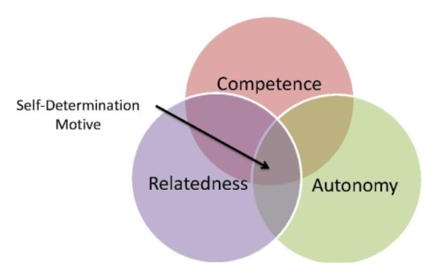
Anthropological building blocks for your own educational pedagogical vision
In this section we wanted to make you aware of how you can arrive at your own perspective from the Dalton concept, your view of humanity, your answers to questions of life and your orientation on personal development and what is necessary for a child to achieve self-realization. This awareness is essential to raise children and to provide education based on broad personal development. It is important to realize your role as a teacher. You are not only a pedagogue, didact and organizer, but also a person yourself and with your individuality and idiosyncrasies an example for the children. If the goal is to provide person-forming education, then you need to bring yourself into the game as a person. This role will be discussed in more detail in section 2.2.5.
When building a personal professional identity, it is important for a Dalton teacher to think about how you relate to Parkhurst's ideas. Is she a source of inspiration and if so, where it can be perceived? How did you 'further' develop her ideas and are there aspects to which you relate critically?
2. Vision on society an on what a human being needs for playing a proactive role
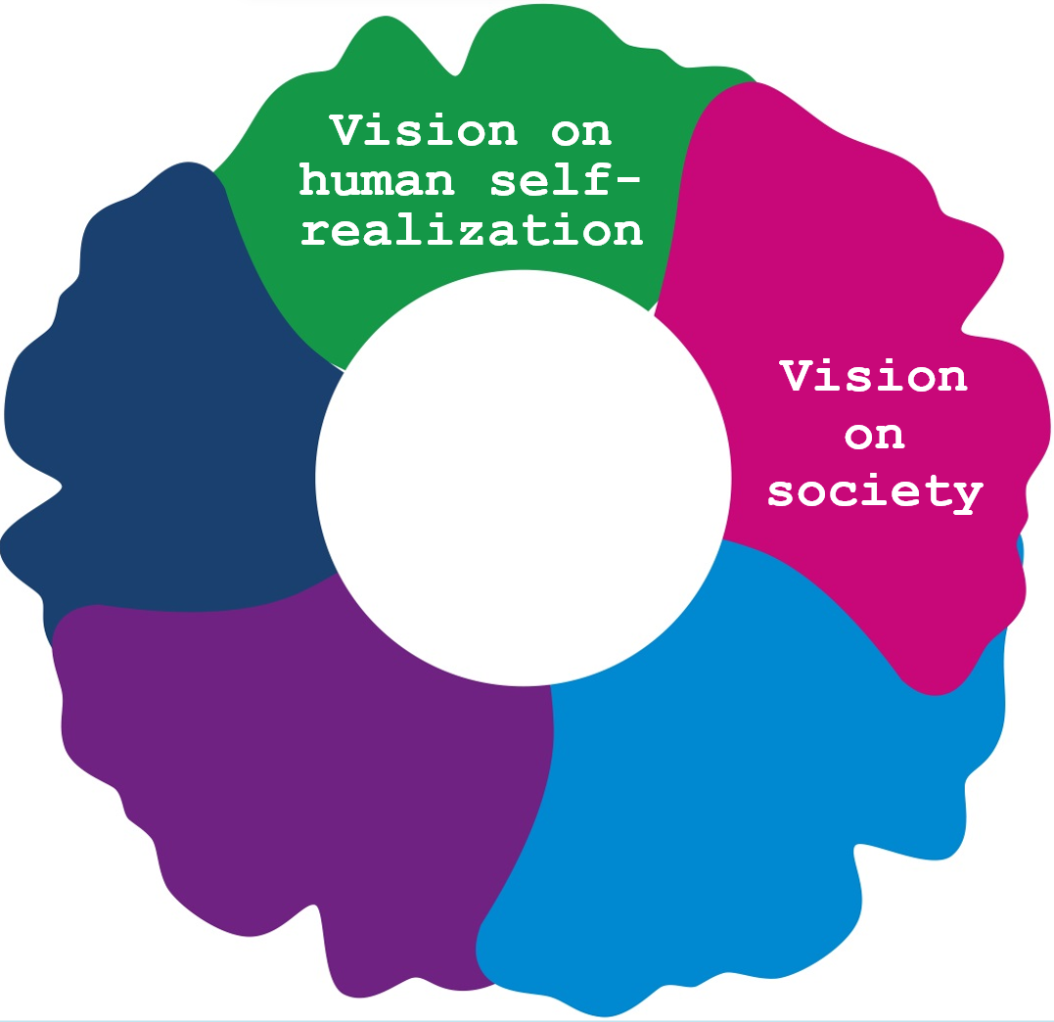

When it rains in society, it pours into education (Kees Schuyt)
It can be concluded from the previous section that for an educational pedagogical vision it is not sufficient to develop (only) ideas about how we can support children to develop themselves as a person (wide). Persons form themselves by learning to relate to themselves, but also by relating to the other and the world. In other words, as human beings we need others as well as the world to shape ourselves. At the same time, in the process of shaping themselves, people also help shape others and that they help shape the world. Personal development therefore also means that we help children to participate constructively in society.
This section first explores what a social vision entails in an educational pedagogical context. A number of important dilemmas from the social force field are discussed, based on which building blocks are then provided for formulating one's own perspective. Even now, the ideas of Parkhurst and Dalton education are considered with the aim of inspiring Dalton teachers to research the building blocks of their own social vision.
Fuel up with inspiration from Parkhurst
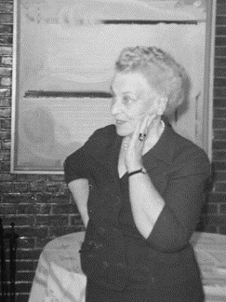
“For service and co-operation are what we need to solve our great political and social problems to-day (…)” (Parkhurst, 1922). Parkhurst does not have a comprehensive social vision. But from the quote above alone it can be read how she views social developments in her time and how children should be prepared at school for an active role in society. Parkhurst thus answers the 'why' question of Dalton education by referring to society's need for people who are serviceable and social. Those are important aspects of being human for her. And she also relates numerous important goals of education to this: the fearless human being, which actively contributes to solving major political and social problems. Dressed up in a more modern way, you could say that she is concerned with broad personal development, in which children are enabled to grow into people who stand in the world in an adult way (Biesta, 2015). It is about moral awareness and acting morally, not looking away from problems, bearing responsibility for each other and for the world and taking the initiative to do 'the right thing'. Parkhurst explains more precisely how she envisions this: “We must not only extend knowledge generally, but also apply knowledge to the service of mankind, so that each individual may be set free to use his powers to the best advantage” (Parkhurst, 1926). Kinderen moeten de kennis, vaardigheden en attitudes ontwikkelen om zich in te kunnen zetten voor de samenleving:
We have to provide opportunities (…) to learn not only how to develop (…) intellect but also how to conduct (…) as a unit of society” (Parkhurst, 1922).
Parkhurst is about creating a 'life-like experience' in a school that is designed as a mini-society.
Wonder as a basis for moral action and social involvement
Western society individualizes. There is a decreasing connection of individuals within social connections, which has to do with tendencies such as de-traditionalization, de-institutionalization and pluralization. This means that people increasingly make their own choices in their own lives. You could say that the personal is no longer social and the social has become personal.
An important parallel process is that of secularization, with the result that the religious determines morality less and less. As a result, the sense of norms has also become more of a private matter, which according to some individuals has led to a crisis in the legitimacy of traditional authority (WRR, 2003). In other words, it is no longer the scriptures or the traditional authorities that so much enforce moral action. This development implies that in moral culture the source of authority is shifting from 'outside' to 'inside'. For some, this leads to a form of moral unease. Others see this development as a form of moral emancipation. Morality is no longer 'forced' for them, but 'internalized', because people develop their own moral compass.
What is morally right, what is required in a particular situation and what may need to be omitted are increasingly independent judgments of individuals. You could say that man is condemned to 'thinking without banisters' (Arendt, 2009): thinking without railings. 'Being human' and 'being in the world' should therefore be in dialogue. This applies to teachers themselves and can also serve as a guideline for their education. It is about teaching children to be in the world without placing or believing themselves at the centre of that world (Biesta, 2018). It is about letting children discover who and what they are and become, but also about teaching them how to be and how to act.
Fire is lit on fire
Biesta (2015) formulates the pedagogical task of broadly training children as children in an adult way 'into the world' and lead them to adulthood. Then teachers also must ask themselves how they view that world. An educational pedagogical vision is therefore not possible without the dimension of a vision of society. When it comes to helping children find their place in society, we need to think about that society and how we support children in this.
In the broad personalization that Dalton advocates, it is important to realize that the context in which this takes place is the school. We will discuss this in more detail later, but because of that context we must also be aware that the school – education in general – has a social interest as well as a personal interest for the child. At school, new generations are introduced to the existing culture and important values ​​and norms are passed on. In this way society is maintained and it is reproduced, as it were. At the same time, the aim is to equip a new generation to shape the renewal of that society. Society is not static but evolving and that requires children to be helped in the future to be able to actively participate in society and contribute to social changes.
Der Mensch kennt nur sich selbst, insofern er die Welt kennt, die er nur in sich und sich nur in ihr gewahr wird. (Goethe)
The above means that humanity is developing a new relationship to morality, which wilfully or unintentionally makes the school a playground for morality to be taught. There are therefore two important educational pedagogical questions in this regard:
(1) What should we do to develop in children a sense of responsibility and an inner moral judgment that is not conditioned or coerced but arises from "inside"? The answer to that question goes beyond self-responsibility. It is also about feeling responsible for the other person and the world.
(2) How do children arrive at actual moral behaviour from a value consciousness? And that is a whole different story. For example, the WRR (2003) stated that awareness of norms and values ​​does not mean that they are converted into actual moral and just action, that the rights, interests and wishes of others and society are considered. It is a question that also needs to be answered for Dalton teachers. It is of course important that teachers 'live before', that they set an example. For the specific situation of a Dalton school, we refer in this context to the 'parallelity principle' (Wenke & Röhner, ????): What applies to children also applies to teachers. Being a teacher at a Dalton school means preach what you teach. We will discuss this principle in more detail in section 5.1.
Without placing the heavy burden of bearing responsibility for 'the' world on the shoulders of children, the starting point for the development of such a moral compass can be found in the child itself. Children are curious. Whether it is an earthworm under a paving stone, the starry sky or a blacksmith stoking his fire, children are interested. Wondering about the beauty of their environment is the basis for children to develop a sense of responsibility.

3. Vision on play, learning, forming and development
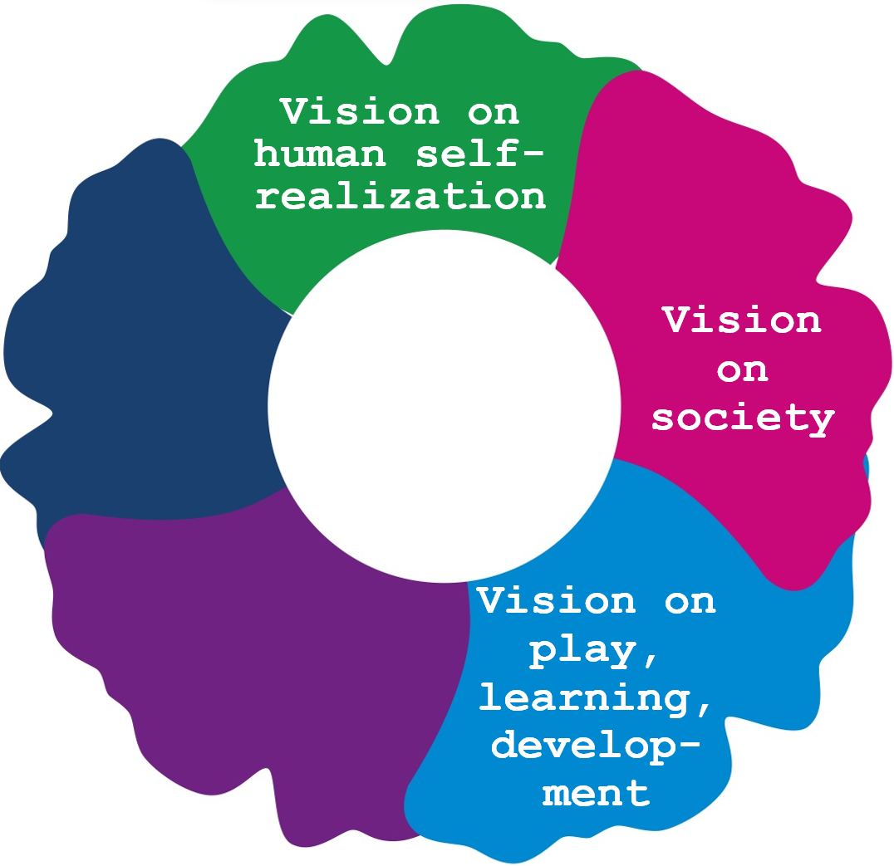 | 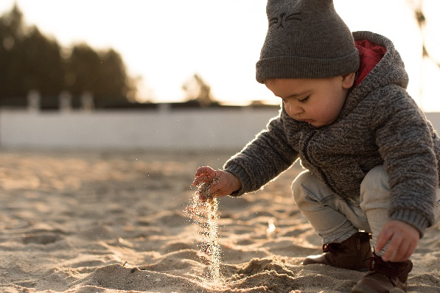
In the two previous paragraphs, we looked at the question of what we are raising and teaching children for. In the first paragraph, attention was paid to the development of a human image, what a child needs to achieve self-realization and thus to grow into an independent person. In the second paragraph, the question is asked about the vision of how children can be prepared to play an active role in society. We have described that it is also necessary to think about how you view society as a (Dalton) teacher.
In order to build an educational pedagogical vision, it is then necessary to be aware of our own vision of how children play, learn, form and develop. This concerns a vision of how children at school can grow in an effective and efficient way into people with guts who contribute constructively to society. We offer numerous building blocks for this in this section. It should be noted that it is difficult and, in a sense, arbitrary to distinguish building blocks for such a vision from tools for putting that vision into practice.
In this section we first briefly discuss the concepts of playing, learning, shaping, and developing. Then we fill up with inspiration at Parkhurst and discuss a number of aspects of a Dalton vision of playing, learning, shaping, and developing. This is achieved around five themes: (1) motivation, (2) experimental experience, (3) personalized learning, (4) learning to learn and (5) learning in combination with the Dalton core values. Section 4.1.2 describes in more detail what 'learning the Dalton way' can mean. Finally, in Appendix 3, a number of themes are discussed for reflection, with which Dalton teachers can become aware of their own vision and with which they can further enrich that vision.
With zero mistakes I have not learned. I only did what I already could!
Play, learn, shape, and develop
It is understandable that in developing a vision of children's play, learning, formation and development, teachers can use more backgrounds than can be discussed in the context of this section. Be sure to use other literature, for example from learning, motivation and developmental psychology about play and play guidance, about broad education and learning. It is important to think about and continue to think about such a vision, because the idea about what the meaning of play is and about how processes of learning, forming, and developing take place, determine every day how you play your role as teacher fills in.
Building a personal vision on playing, learning, forming, and developing has of course everything to do with the goals that are intended. There is therefore a direct relationship between the content of this section and what has been discussed in the previous two sections, with what a child needs to grow into a person with courage who contributes constructively to society.
Do not consider the contents of this paragraph as a summary of all available knowledge about learning and development, but as a number of statements with which you can sharpen your own vision in dialogue with others.
We begin with a brief description of the four separate concepts that must be seen together: play, learning, form, and development.
To play
Play is a completely serious matter. It is the work of younger children. They are active in their game. They explore the world, process, and practice what they have learned in their game. Play is thus an expression of man's inner self, in which he develops and forms himself.
As children grow older, play develops into learning to play and learning through play, but it is important that we also keep an eye on the value of play in older children.
To learn
Learning is quickly regarded too one-sidedly as the acquisition of knowledge and skills, but it is broader in scope, including cognitive, physical, creative, and artistic, motor, social, moral, and emotional development. Moreover, it is valuable to distinguish between formal and informal learning. Going to school is not the starting point for learning, perhaps it is for more conscious, planned and formal learning.
Learning cannot be forced. Teachers can invite, facilitate the process, but the student will have to learn for himself.
To shape
Formation is a concept that we have already discussed in section 2.1.1. It has been said – in the context of Dalton education – that it is about the formation of an independent person. What is also important is that children need a context in which and in which they can form. That context must be meaningful and functional. What they learn in that context must be able to be applied and experienced.
To develop
The term development stands for 'being on the road'. It is an essential characteristic of man. He may have expectations about this and desires about the direction in which that development takes place. Development has a destination or a goal, but that is often still completely unclear. The word "develop" also presupposes that there is something to "develop," a genetic predisposition: there must be such a thing as the potentialities within man that unfold. The question is to what extent humans can influence this and make choices.
Each child develops at their own pace. In the context of a (classical) school, this leads to numerous dilemmas. For example, if we talk about average development and the development of children is compared with it, this leads to the question that Luc Stevens asks himself: Can children get an unsatisfactory mark for development?
A field of tension is also the question of what the essence should be in the supervision of development processes: 'führen' or 'wachsen lassen'? And what is the role of 'nature' versus 'nurture' and of 'maturation' versus 'learning'?
Fuel up with inspiration from Parkhurst
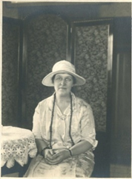
Parkhurst was curious about children's learning: “I am very much interested in the laws of learning, and all those conditions in the school which not only make learning possible, but which make not learning impossible” (Parkhurst, 1929). En het is voor haar volstrekt duidelijk: “Children like to learn (…) It is not so much what as how they are taught which is at fault in our system!”
According to Parkhurst, the basis lies in the natural interests of the children. The teacher should not see this as an enemy, but rather as a friend. Children want to learn, want to develop, and want to do. Being busy, curious, and enterprising, exploring, trying out together and experimenting suits children. According to Parkhurst, they crave to work experimentally “for real”: “Experience for which a craving exists in every youthful heart” (Parkhurst, 1922).
In fact, Parkhurst thinks there is nothing more instructive. Real learning is experience. It is about learning to live by living, learning to work by working and learning to learn by learning (Van der Ploeg, 2010). Röhner and Wenke (2002) state: “Children want to gain experience. They want to experience things, to be brought into circumstances that challenge them to take initiatives. They want to be able to experiment and do not like pre-conceived patterns that are not allowed to improvise.” Experiencing meaningful work in real-life situations liberates children and that is what normalizes children's behaviour as well. It is about learning in and from meaningful, authentic, and functional situations.
She also indicates that children want to be taken seriously and find it interesting to be given a task that they can tackle at their own discretion, in their own conscience, without being dependent on others. They become enthusiastic and find it interesting when teachers look for a form of 'ownership' with them. Control is necessary for this. Parkhurst gives children a voice in their own learning and in the education that is organized for that purpose. As a result, they do not learn for the master or the teacher, but for themselves and for life. This experiential learning experience and ownership together contribute to intrinsic motivation: “Learning must be fun!”
She warns against indiscriminate memorization: “Pure memory work is difficult and a burden to the mind.”
Parkhurst speaks of 'the liberation of the child' and it does not do that by keeping students passive, by separating them, by holding them in place, by keeping them still, by letting them memorize lessons. and by having them recite lessons (Van der Ploeg, 2010). Then learning also connects to the spontaneous, childlike development, learning quickly becomes 'as exciting as playing' (Parkhurst, 1922).
It is also essential that children set their own goals and gain insight into the school goals and that they bear responsibility for the execution of the work that has to be done: “Children learn, if we would believe it, just as men and women learn, by adjusting means to ends. What does a pupil do when given … responsibility for the performance of such and such work? Instinctively he seeks the best way of achieving it. Then having decided, he proceeds to act upon that decision. Supposing his plan does not seem to fit his purpose, he discards it and tries another. Later, he may find it profitable to consult his fellow students engaged in a similar task. Discussion helps to clarify his ideas as well as his plan of procedure. When he comes to an end, the finished achievement takes on all the splendour of success. It embodies all he has thought and felt and lived during the time it has taken to complete. This is real experience” (Parkhurst, 1922).
Parkhurst also believes that learning is a social affair. She believes that children should be able to consult each other in an open atmosphere, be able to help each other, work together, and learn from and with each other. She even calls cooperation her second principle. She is therefore not only concerned with 'the liberation of the child' but also with 'the socialization of the school'.
Parkhurst's basic ideas about 'learning the Dalton way' are mostly reflected in Dalton education today, although new insights have of course been included. Roughly speaking, building a Dalton vision on play, learning, form, and development revolves around five themes: (1) the importance of motivation, (2) the importance of experience, (3) personalizing learning, (4) learning to learn and (5) learning in combination with the Dalton core values. These five building blocks are elaborated below. Of course, the five themes are related to each other. They are distinguishable, inseparable. In paragraph 4.1.2 of Dalton: L E F a number of concrete elaborations of this are given.
1. the importance of motivation
Motivation is an essential part of a Dalton vision of playing, learning, forming, and developing. This concerns, among other things, the importance of being active yourself, that learning is about gaining real experiences, about experiencing the usefulness and necessity of learning, about experiencing satisfaction and competence in learning and about addressing children on their imagination and creativity.
‘Self’
My grandmother used to be taught how to sit still.
Children are hands and mouths, they are curious, 'investigative' and 'discovery'. They are action-oriented from birth. You finally see them try and repeat, until they can do it themselves. Children want to grow, learn, work and above all do it themselves. They have a genetic predisposition to do so. Learning happens to children; it is part of growing and growing. They want to gain control over themselves and their environment and to take ownership of their own learning and development process.
The well-known Dutch mathematician and physicist Robbert Dijkgraaf once said it aptly: It is not so much a question of adults having to press children's 'on' button, as of keeping them off the 'off' button. Children are curious and have an inner drive to develop. The problem, however, is that when that natural propensity for activity is hampered, when that self-acting is curbed, when children are kept short by protective curling parents who go 'helicopter', when they are chained to a buggy instead of themselves. If teachers give too much supply-driven education because they are worried about their returns, the child can be 'tamed' into an uninitiated child, who sits down and waits for them to be fed, for the teacher to do his trick does or until he gets an order. The consequence is that - in order to get them out of consumer mode again - you need, so to speak, a course in activating didactics to get those children 'starting again'.
Dalton teachers therefore have a mission to keep children in action mode as much as possible; let them figure it out for themselves, let them try, let them experiment.
For real
Children learn for life and not for school. In the past, when it was not yet possible for all children to go to school, children learned the necessary knowledge and skills for life by 'playing along' in real life.
Game and learning situations in which real life and current events are or are imitated are still highly preferred in education. It provides a meaningful context for learning and for application learning. Real-life situations facilitate the transfer of what has been learned, but also provide motivation because children immediately experience the practical usefulness of the learning material. It is what Freinet meant when he wrote: "No one likes to do things in which he is not personally involved and whose meaning and significance eludes him."
Such forms of experiential learning are, of course, not always feasible, but it has great advantages to keep looking for them. For example, why would you let children practice writing a letter on a blank worksheet of the language method?
For this reason, many Dalton teachers use as many authentic materials as possible for corner work in their lower grades. All the toys and all the materials and resources developed for educational purposes seem tempting, but there is nothing like 'real' materials for learning about and in the 'real world'.
This desire to let children learn in real life sometimes also leads to frowning when people learn about the content of method lessons.
Usefulness and necessity
The kindergarten teacher walked out of the school with his group. They went on a reading walk in the neighbourhood. All children were instructed to look for letters and words during the walk. This is how the children discovered how important it is to learn to read.
If children really want to master something themselves, they practice until they drop, so to speak. They will know or be able to do it. That perseverance strengthens will development and is character building.
Ellen Key wrote in 1900 in the famous book The Age of the Child: “The school should not teach until the child first desires to hear or do something himself, for which only more knowledge can help him.”
In an educational context, this wish is not very realistic, but on the other hand, the motivation for the subject matter at school is rarely intrinsic. This means that we run the risk that children will go to work because the teacher gives them an order or even to avoid punishment. Then it will be a long time at school for children.
It helps enormously if teachers start asking themselves how children can be made clear about the usefulness and necessity of the school curriculum. Attention is then paid to a curious, problematized meaningful context and to transfer: the application of what has been learned in meaningful, functional situations for children.
Satisfaction and competence
When thinking about the importance of motivation for learning, it is a surprising insight that learning does not have to be fun at all. The drive to make it fun is mainly related to teachers' concern that children have little interest in what teachers offer them at school.
Learning is often a matter of working hard and always trying. Children often must learn to overcome failures before they can taste the sweet happiness of success and celebrate the achievement of the learning goal.
It is not necessarily about learning to be fun. It is about satisfaction, to finally master it, to know it, to be able to do it. The only wonderful thing is packaging, a gift wrap. And the more meaningless the gift is, the more beautiful the wrapping paper.
Motivation in learning is indeed important, intrinsic motivation is even desirable. But it is less about 'fun' than about satisfaction.
The self-determination theory of Deci & Ryan (1985; two thousand) points out that, in addition to physiological needs, human motivation is determined by three natural, innate psychological basic needs: (1) the need for autonomy, (2) the need for (relational or social) connectedness and (3) the need for competence. Satisfaction is related to the need for autonomy and competence. Whether it concerns their own learning wishes or school goals, if children accept schoolwork as their 'job' and they do not work for the teacher, but for themselves, then the need for autonomy is satisfied. Then learning does not even have to be fun. The work is then important for the child. And if you successfully complete your own 'job', this satisfies the competence need and makes completing the work satisfying.
The value of curiosity, wonder, fantasy, and imagination
Did you know that a wombat poop square turd? Why would he do that?
Children are extremely interested in exploring the world. There is also so much beauty to discover! That is why education has been described as 'introducing meanings'. But it could have been a little more 'disguised'. Many teachers say they find it important to connect with the living and experiential world of children, but we also must realize that it is important to let children transcend their own living and experiential world. It is about learning new things.
2. Experimentation
Parkhurst believes that concrete experience is the most important form of learning. She does not mean so much the experiential or discovery learning that is extensively used as forms of inductive learning and of problematizing didactics within the subjects. Rather, it means a form of experiential learning, in which general, cross-curricular skills are developed in, for example, learning to plan tasks. And it is important to her that learning is about creating meaningful contexts for learning and the use of authentic materials, which might especially be used and applied in real life.
Experiencing ensures that children become involved (‘involvement’) in learning. This can be stimulated if the learning for children also has a purpose, that it serves something for them. Children do not get excited about 'working for the trash', but they do when it learns for themselves, and it's not forced.
First-hand and second-hand knowledge
The experimental nature of learning ensures effectiveness of learning. Kessels (????) shows how this works. He makes a distinction between first-hand and second-hand knowledge. First-hand knowledge is knowledge that you make your own. You have solved a problem yourself and you have acquired the knowledge that is necessary for this yourself in an experimental way. It is a skill that you will never lose. Second-hand knowledge, on the other hand, is knowledge that you have learned after an explanation. It has been taught and passed on to you. And that knowledge is always less effective because you always must draw from your memory, no matter what it was or had to use it again in a new situation. And that process often goes awry because knowledge that has been transferred, instructed, is 'second-hand'. It depends on how well you can still remember the solution and how well your memory functions, whether you can still reproduce the knowledge. It argues in favour of creating as many situations as possible in which students can acquire first-hand knowledge in a self-directed manner. In this context you could therefore say that (Dalton) teachers should not sell solutions but should sell problems.
3. Personalized learning
If they had told us that education has a purpose, we could have thought about how we could achieve that goal

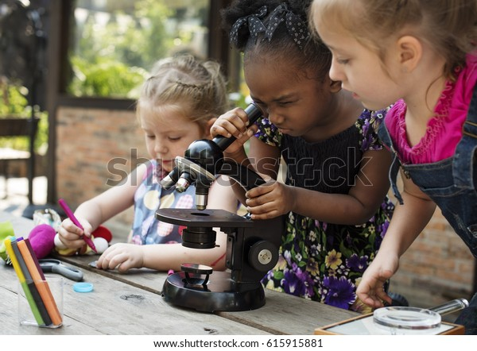 | 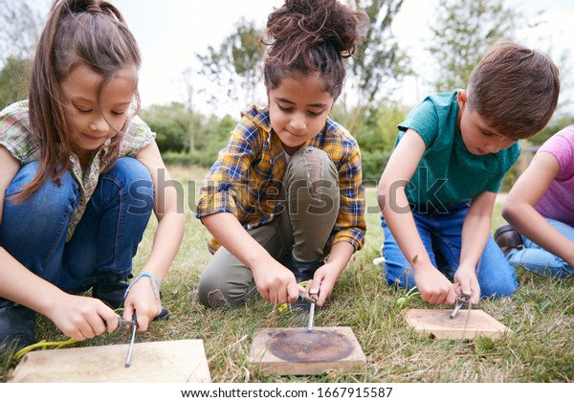
Learning and development is completely personal, 'something' of the individual, of the person himself. We can create a prepared environment, invite children in all kinds of ways, facilitate the process, but whether a child learns and develops and then also learns what is meant in the school context is always a question. It makes the teaching profession a 'risky' undertaking (Biesta, 2015), because whether all facilitating actions by the teacher have the intended result is always questionable.
Every teacher and every parent also know that children differ from each other in the way they learn and develop, in the time and pace of learning and development.
And because children have a legal right to an uninterrupted developmental process, it is essential that teachers tailor their teaching to the level, pace and needs of the children. That is, among other things, what is meant by the term appropriate education. Education should be appropriate for every child. This does not mean that education should necessarily be individualized, but that there is an eye for the uniqueness of each child.
Because every child has to ultimately learn for himself, in order to realize the goal of education and upbringing to become self-determining and self-responsible, it is an explicit wish in Dalton education to give children a voice in their own learning and in the education that is set up for that purpose. Where possible, the aim is for children to take ownership of their own learning. And that means that the teacher not only tailors the education to the children, but above all that the children learn to talk about it and make decisions with them. In summary, we call this personalized learning. The point is that the teacher and the student are at the wheel together. Briefly, which is what Parkhurst is all about: giving children a voice in their own development.
4. learning to learn
A young child 'happens' to learn and develop, as it were. But during his school career, a pupil will become increasingly aware of the process of that learning and development. It will find that he is learning and what he is learning, how he is remembering something and how he is mastering a skill. It will also discover that others may learn differently that there are alternatives to its way of learning. And that forms of learning can be spoken of in terms of handy or inconvenient, effective, or ineffective, efficient, or inefficient. In talking about and becoming aware of that learning, the child will also discover that there are sometimes more useful ways of learning than the way in which he approaches it. Children will discover that sometimes there is more than one solution strategy to use.
Dalton education wants to teach children to take (more) responsibility for their own life, their own work and therefore also for their own learning. The latter is only possible if children become aware of how learning processes in general take place, and particularly how this happens within themselves.
Building a theory about own learning
Discovering and learning things in a playful way happens to a child, without being aware of that thinking and learning. It is a spontaneous, implicit process of which a young child is unaware. But as children grow older, children are increasingly able to develop ideas about how their own learning takes place, how it can be planned and what can best be done for it. You could say that Dalton education encourages children to develop a theory about their own learning. Because if children have to learn to take responsibility for themselves, it also requires being able to reflect: Who am I? What can I? What do I want? How do I learn? Where am I in my learning and how do I work in an effective way?
Learning to learn
Processes such as planning, monitoring, and reflecting on learning play an essential role in developing knowledge about their own learning.
This means that attention is needed in Dalton education for executive functions. These are control functions in the brain to target and control (learning) behaviour. We thereby determine the purpose of our actions, eliminate distracting factors, and plan the sequence of actions. We carry out the tasks required for this step by step and monitor the effect, also taking possible future effects into account. We regulate emotions, motivation, and alertness with it and allow past experiences to play a role in expectations and decisions for the future (Dawson & Guare, 2009). In other words, executive functions enable self-direction. They are, as it were, the 'conductor' of our (learning) behaviour.
Research into self-direction has led to the insight that self-directed learning cannot be learned in a self-directed manner (Vrieling, 2014). This means that it is not enough just to give children the opportunity to learn in a self-directed way. Strategies for cognition and metacognition, motivational strategies and regulatory strategies for behaviour and the use of materials and space must be learned intentionally and explicitly. Sins (2019) developed an approach to give students instruction and help with self-directed learning, iSelf. We will discuss this in more detail in section 3.2.2.
Instruction in self-directed learning should not take place in separate study skills lessons. Research that Sins cites shows that the required approach behaviour must be taught during regular lessons, for example in language and math education and in world orientation.
Talking about learning
If you cannot make a mistake, you cannot make anything (Marva Collins)
In the context of learning to learn, it is also desirable to talk about learning with children in general. It is actually quite remarkable that talking about learning happens little, while children are expected to learn a lot throughout the day.
When conducting conversations about learning, all kinds of aspects of that learning can be discussed.
For example, consider the importance of making mistakes. After all, you learn from making mistakes. It is the fastest way to learn. But when people are afraid to make mistakes, they play on the safe side. Then they no longer dare to try and experiment. Then the focus is on preventing mistakes and that is not conducive to learning.
Such conversations about learning can also be referred to as 'the learning pit'. If children know beforehand that it is very natural in a learning process not to understand it, not to know or not to be able to, and that it is difficult, but that you can do something about it to reach 'the other side', then This helps in gaining insights into how learning processes are carried out.
The idea of ​​the learning pit comes from the Mindset theory of Dweck (2012). She distinguishes the 'growth mindset' from the 'fixed mindset'. Children with a growth mindset act on the belief that intelligence is something that can be improved. If you work hard enough, you can learn to master certain actions well. A child with a growth mindset is more likely to take on challenges and look for challenges to improve himself. On the other hand, children who have a 'fixed mindset' take on as few challenges as possible and continue to perform tasks at which they are already good. They believe that you cannot improve intelligence, that it is innate, and that failure is therefore impossible, because it shows that you are less intelligent. These children avoid negative feedback and rarely improve on their weaknesses.
When talking about learning, one can also talk about differences in approaches to learning, where and how you can best learn with concentration, at what time of day you can learn something better or less well, with whom you can work best, et cetera. By talking to children about alternatives, you can challenge them to sharpen their own learning behaviour.
5. learning in combination with the Dalton core values
You learn to make independent decisions in freedom at a Dalton school by making independent decisions in freedom. The ability to live, work and learn together is acquired by living, working, and learning together. And children also learn to take responsibility and reflect through practice. To develop a Dalton vision on playing, learning, forming, and developing, it is therefore important to think about the relationship with the various Dalton core values.
Regarding the core value of freedom in bondage, at Dalton schools we give children the opportunity to choose freely, but we also instruct children who need support to choose freely. The same goes for taking responsibility and being accountable. Children also learn this through experimentation in practice, but also through instruction and guidance.
The same applies to learning to work independently. Children are given many opportunities to do it themselves. Sometimes this requires instruction or a kind of a form of help or coaching. Where independent work is given the deepening of self-directed learning, explicit instruction is a requirement, as we have already said.
Children like learning (rather than like to learn) from and with each other. Being allowed to do things together, being allowed to learn together is stimulating for the learning of every individual. The way in which this can be done is very varied at a Dalton school: from helping and assisting each other, performing group work to cooperative learning. In the latter case, the learning outcome of each of the children depends on that of the other. Moreover, for the core value cooperation applies that children do not only learn the desired skills by giving them the opportunity to work and learn together. Explicit instruction is required in many aspects of collaboration. This can range from becoming socially skilled, considering each other, fulfilling distinct roles during group work, to using collaborative and cooperative working methods. We will talk about that in part 4.
More or less the same can be said about the Dalton core value reflection. Providing the opportunity to reflect is important, but often children must also be instructed to learn to reflect before they can use reflection skills functionally to learn.
At Dalton schools, learning does not always follow the steps: instruction, supervised practice, and independent practice. Not all learning needs to be preceded by instruction. Sometimes that instruction in advance is important, sometimes it is desirable to let children try themselves first and sometimes it is desirable to reflect during and after learning.
Building blocks for a vision of playing, learning, shaping, and developing
This section discusses five themes for developing your own Dalton vision on playing, learning, shaping, and developing. It is important for teachers in Dalton education to be aware of their own views on these building blocks. In appendix 3, a considerable number of elements from this section have been collected to arrive at such a vision.

4. A vision on the role of the teacher
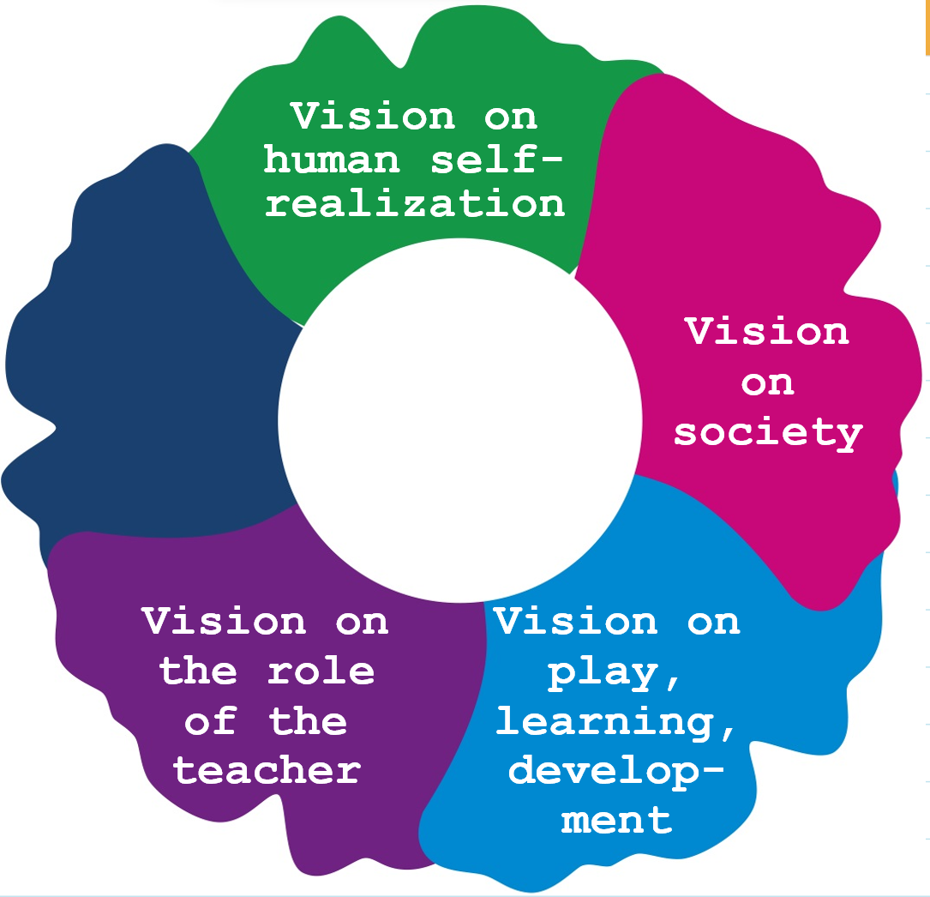 | 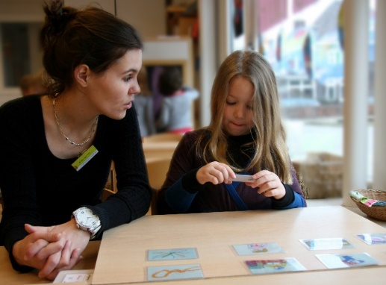
A view on the role of the teacher is also part of a broader educational pedagogical vision. The question here is which function the teacher ascribes to himself. Such a view can vary greatly, and you can ask questions about all these considerations. For example, have you ever gone to the teacher training college 'to go to class'. Okay, but central to the board and to the classroom is that the place you assign to the teacher. Did you go to primary school to instruct children something? Okay, but isn't it true that children learn on their own? You cannot do that for them, can you? Or perhaps you went to the teacher training college to teach children? Also OK, but does that 'teaching' of you mean that you mainly think that you have to 'send'? Or do you think it is more about guiding the development and learning process in children?
This section discusses various ingredients of such a teacher's view of his own role. It also tells how Parkhurst viewed that role and how an idea developed from her ideas about teaching in Dalton education. We also conclude this section with numerous questions to make explicit our own vision of the role of the teacher.
Fuel up with inspiration from Parkhurst
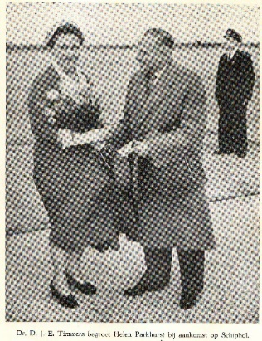
Parkhurst says interesting things about the teacher's role in her Dalton Plan in several places in her publications. First of all, teachers should realize in all their work that Dalton is 'a way of life' for them. But she also believes that teachers should not blindly follow her ideas.
“Dalton is no method, no system. It is an influence," she says in 1952 when she visits the Netherlands (Timmers, 1952). By this she means that teachers should experiment and reflect on their experiments. She wants teachers to look for efficient and optimal working methods in a practical and pragmatic way.
Parkhurst also believes that the teacher himself is a carrier of culture and should commit himself as a person. He is an example for students to focus on. Where students are raised and taught to become 'fearless human beings', the Dalton teacher is asked to be a 'fearless teacher'. Parkhurst points out that teachers in her day "hang their personality on the coat rack when they enter the school in the morning." She states that they do not dare to show their qualities to students, probably afraid of losing their prestige. For Parkhurst, however, it is important that teachers dare to show themselves as a person to the children.
One of Parkhurst's most interesting statements about the role of the teacher is, "Stay out of the way!" She calls on teachers to remove obstacles that keep students from working. Pupils must work and therefore the teacher should not meddle in matters he should not meddle in. They must set up the environment in such a way that children can get to work and keep working.
This does not mean that teachers should not give instruction. Standard instruction moments are included in its structure of the 'assignments' (tasks). Today, in Dalton education, we even wonder whether those instructions are always necessary for all children. There is plenty of experimentation with children to register on instructions. For Parkhurst, the teacher's role is primarily one of facilitator or coach.
Because Parkhurst wants to design education in an integrated way ('synthetic education'), the teacher must: “(…) ever be on the look-out for inter-relations and so stir within the minds of the children the faculty of creating channels between the different territories – channels which will fertilize the whole earth between them and give that infinite joy.” And that requires a kind of 'total vision': "Such total vision must be constantly in the mind of the teacher" (Parkhurst, 1922).
A special requirement that Parkhurst places on teachers is that they always make the assignments themselves. That is the only way to optimally attune to the children. Parkhurst writes that in 1922, but already in the same year 'assignments' are published for various subjects. It is also almost an illusion to have the composition of tasks done by teachers themselves.
As a practical person, Parkhurst realized better than anyone that educational practice is full of unexpected moments, in which teachers constantly must improvise. It typifies Parkhurst as a pragmatist that she asks teachers to prepare education well, but at the same time it is also about “Solving problems as they arise!”
Love, trust, dedication, curiosity, and seduction
When students deal with issues that they consider vital, then there is good education. When students are concerned with understanding the differences between people, then there is good education. When students are supported to understand concepts instead of just being presented with isolated facts, then there is good education. When students are actively involved, then there is good education. When pupils work in heterogeneous groups, then there is good education. When students are busy critically assessing and perfecting their work, then there is good education. When students reflect on themselves, their own lives, and their beliefs, then there is good education (Haberman, 1991).
Although you will sometimes want to stick them behind the wallpaper, being a teacher is primarily based on love for, trust in and dedication to children. That is the basis that children need to use the space and time in freedom to get to know themselves and to develop. Teachers get interest, enthusiasm, and enthusiasm for the profession from working with children. There has never been a teacher who says that he chose education because the meetings are so nice at school.
To nurture children's curiosity, teachers themselves should also be curious and open to new impressions. Only then will teachers be able to play the 'game of seduction' with their children because teachers must be able to take children along in education.
Optimism and high expectations
The basic attitude of teachers is also that they are optimistic about child development and about realizing their potential. That optimism may extend even further. Teachers must trust and have high expectations that children will make a difference and that they will contribute, each in their own way, to a better world. The possibilities for this in and of the school may be limited, but the main idea is that every success should be celebrated. This is where teachers get their satisfaction.
Ownership of the profession
Education seems to be increasingly positioned as a tool to solve a whole range of social problems. This is a functionalist view of education, in which the teacher is increasingly seen as a 'conduit'. That is essentially an attack on the intellectual freedom and skill of the teacher. The teacher can increasingly only choose how he implements the agenda, no longer determine the agenda himself. However, Biesta (2015) believes that, in addition to the form, teachers should also determine the function and content of what happens at school. And this requires emancipation in which control is recaptured.
Balancing what society requires from the school and what the child needs requires a balance that only the teacher can find between acting effectively and efficiently and the wisdom to judge what is desirable for these children here and now. is. Finding such a balance is a risky undertaking with an uncertain outcome. But society has no choice but to give the teacher confidence in this and the space to decide for himself. Kelchtermans (2013) speaks in this regard of the professional space of the teacher. Even though education may seem against it and getting children from A to B seems a logical and simple idea, the processes involved in education are complicated (Labaree 2003, 2004 and 2006). The teacher must continuously anticipate and fine-tune his teaching, while constantly considering which goals should be pursued, which contents, working methods and organizational forms are desirable or should be omitted for this individual child or his/her own group. Constantly having to make such assessments and to look for nuances makes teachers vulnerable (Kelchtermans, 2013). It requires wisdom, pedagogical tact, practical wisdom, and judgment from teachers. It is sometimes literally about holding children with the aim of letting them go, offering structure to teach them to deal with freedom and setting rules to teach children to bear responsibility.
Teachers are, as it were, simultaneous chess players on twenty-five boards at the same time, says Biesta (2015). And to develop the metaphor a little further: the chessboards are also multi-dimensional. On each board and level, children desire different moves. Education can therefore only be effective if (Dalton) teachers attune to the children and to the circumstances of a specific moment. No matter how well things are planned, something unexpected can always happen. Suddenly a wasp flies through the classroom, a planned instruction is not understood, a pot of paint falls, a child brings a present from home. Education is therefore always a 'risky' affair that requires improvisational talent. But that risk is precisely the risk that teachers like to take. Education is about people, about children: living material. That is why an enormous talent for improvisation is necessary. Biesta (2015) therefore speaks of a wonderful risk.
Pointing to the teacher's necessary 'fingerspitzengefühl', Biesta (2015) uses the concept of the teacher's virtuosity. To develop and demonstrate this virtuosity, the teacher must regain (more) ownership of his own teaching. Kelchtermans (2013) points out that to be able to use this virtuosity, teachers must also claim professional space to develop and implement that craftsmanship. This allows teachers to respond to changing situations and unexpected events. And that includes the fact that the outside world has confidence in the teacher's performance and craftsmanship.
The roles of the teacher
“The quality of an education cannot exceed the quality of its teachers” (McKinsey-rapport)
The teacher's task is to help young people, who are not yet adults, on their way to adulthood and full humanity (Noordam, 1970 a and b). This means that the teacher must be aware of a human vision. Anthropological principles have important implications for educational pedagogical practice. That is what Langeveld calls the anthropological principle. Doing his job well requires teachers to take stances on what “being fully human” means. And the conversation about opinions and about differences is important. Noordam (1970) is adamant about this: “Neutrality does not lead to true humanity. Only when each person contributes his deepest conviction to living together, so if he is not impartial, but is honest with the other, can an ideal of humanity be built.”
Children need the teacher for their own education, if only as an example and because the teacher can be expected to bring himself into play. It is about his opinions, his culture, his attitude, his way of building relationships, his answers to life's questions, et cetera.
In addition to the role that the teacher plays as a pedagogue, didact and organizer, he is also important as a person.
The teacher as researcher
Martens et al. (2020) argue that the teacher's actions are always entirely from this one teacher, influenced by all kinds of conditions. The authors indicate that this action includes reflection on that action. That is why the teacher is always a researcher of his own practice, a practice in a complex context in which people (children), processes, changing conditions, interventions and systems constantly interact.
Systematic reflection or systematic discovery occurs in the behaviour of teachers in numerous guises. This can vary from a personal reflection that comes about through systematic introspection to a form of (quantitative) research into the effects in test scores of an experiment with a new computational approach.
Because teachers are expected to realize their educational vision together and therefore also look for effective and efficient working methods, this requires testing in the classroom and systematic reflection on that experimentation. In that experimental (research) context that is the classroom and the school, every day, through action and reaction, this yields ideas about what works in practice. This is how teachers develop their skills. However, this 'knowing from practice' sometimes conflicts with 'knowing from theory and (scientific) research', which sometimes also brings the integrity of educational practice into question.
It seems sensible that teachers should not look away from this 'knowing from the theory’ but learn to critically question the scientific knowledge provided and learn to relate to it. But such an attitude does require courage and to work (together in a team) from the own educational pedagogical vision.
In concrete terms, this means that teachers learn to relate to 'knowing from theory' and that teachers try to organize their practice 'evidence informed', as Hargreaves et al. (2009) put it. That 'evidence informed' work means that teachers are 'translators' of knowledge to the special situation in their class.
The judgment of the teacher
Martens et al (2020) argue that there is a misconception about the role of the teacher. His task would lie in guiding and supporting learning processes. But education is more. Education is multidimensional. It is not just about qualifying children but teaching them the knowledge and skills from the core objectives. It is also about socializing children and teaching them to develop as an independent person.
This means that society must provide teachers with a form of professional autonomy to give them the space and the ability to develop the ability to make judgments about what is educationally desirable in concrete situations. Pedagogy is therefore about the role that educators play in that development. In education and upbringing, we are not dealing with causal relationships between interventions and effects – the logic of billiard balls – but with relationships between the intended and intended actions of educators and teachers on the one hand and the possible consequences of this action in children on the other. In daily educational practice it is always about the balance between the three target domains: qualification, socialization, and subjectification; to the question of what this child needs, at the time being, in this situation, with a view to a concrete future and considering concrete interests and priorities. And it is up to the teacher who works with this child or children to judge in that. In addition, in the educational pedagogical situation, the teacher does not meet the child as a 'thing' that needs to be educated or trained, but as an independent individual (subject) (Biesta, 2019). There is no scientist, no method developer, no education inspector, or anyone else who can take over the judgment of the teacher in that educational pedagogical situation. The making of such judgments takes place at the heart of the educational process. There, only the teacher can and must act autonomously.
Pedagogical tact
The pedagogical task of the (Dalton) teacher is to ensure that every child feels seen, known, heard, and understood and develops optimally within his or her possibilities. This can be interpreted as 'doing the right things at the right time, also in the eyes of the pupil', which Stevens and Bors (2013) call pedagogical tact.
It is an illusion to think that there is a manual for pedagogical action. Nevertheless, a tactful basic attitude can be developed, which helps to be the teacher you want to be more often. It is about seeing yourself as your own instrument and that teachers, together with the team they are part of, build a strong relationship, also with those children who are more difficult to reach (Van Manen, 2014).
Dalton competencies
He, teachers! Leave us kids alone! (Pink Floyd, The Wall)
General competence requirements have been formulated for primary school teachers, which are described unambiguously and concretely. There has been discussion within the NDV about specifying these general competences for working in Dalton educational practice. Documents about this are circulating within the association with lists of Dalton competences for teachers. However, these have never been implemented as 'mandatory requirements' within the association. Such an overview of Dalton competencies can be found at www.focusopdalton.nl.
However, standards have been described for the courses for the various Dalton certificates issued by the NDV (see, among other things, www.dalton.nl).
5. Visie on the school
In this section, we first ask you to participate in a thought experiment. You start your own school under a shady tree in a village far away. There is nothing there: no building, no blackboard, there are not even tables and chairs. Moreover, the children have no idea about the concept of 'school'. They have no parents or adults around them who have told them what it is like to go to school. When we have lost all form, all the finery, all the materials and all the burden of preconceived ideas about what a school 'is', what remains is the essence of education: children who love stories and who are curious about the world and want to learn about. And there is a teacher who helps them discover that wonderful world. He surprises them with new information, tells beautiful stories, makes them do things they have never done before, experience, see, feel and hear things that are new to them. In this section we want to recapture such a basic idea about the school by asking the question why do we send children to school anyway?
Going to school may be so self-evident that we never really ask ourselves that question. However, we will do that in this section. It is as if we are going to reinvent the school and try to get to its essence. This exercise helps to arrive at your own vision of the social education institute 'school'. It also considers how Parkhurst viewed the school and how the followers of her ideas do so today: the school as the place where children receive broad-based personal education. Finally, questions are again being asked that can help you become more aware of your own ideas about the (Dalton) school as a training institute.
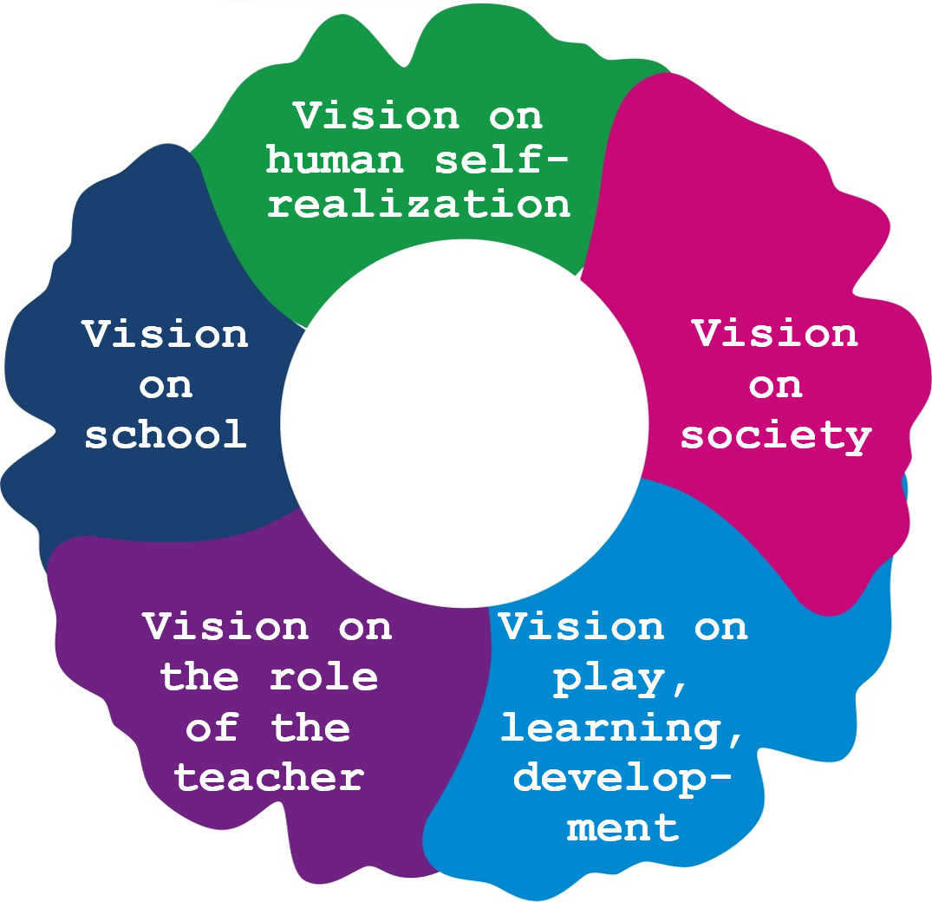

Fuel up with inspiration from Parkhurst
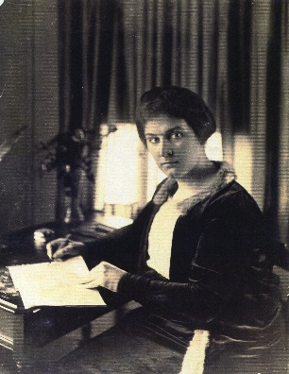
The whole idea behind the creation of the Dalton Plan stems from Parkhurst's fundamental critique of the traditional school. She has nothing good to say about the ineffective and useless authoritarian relations that rule it: “(...) 'Fictious authority', arbitrary authority', immutable rules and regulations (...). It is restrictive, not educational (…). It is fatal to the idea of ​​a school as a vital social unit” (Parkhurst, 1922). In her book, Parkhurst quotes the educator Emerson, whose criticism of the school was also harsh: “We are students of words. We are shut up in schools and colleges and recitation rooms for ten of fifteen years and come out at last with a bag of wind, a memory of words, and do not know a thing.” Parkhurst sees the function of the school very differently: “Let us think of school rather as a sociological laboratory where the pupils themselves are the experimenters, not the victims of an intricate and crystallized system in the evolution of which they have neither part nor lot” (Parkhurst, 1922). The school as a training ground where circumstances prevail as in society itself and where children learn the skills they will need later in society.
Parkhurst sees a number of essential building blocks to realize this new school. Primarily, it must be a school where children gain 'real' experiences: “In the old days the student went to school to get what the school had to offer him; now he goes to school to satisfy a definite need for self-development. He is no longer disposed to learn just what the teacher proposes to teach. The mold (= de mould) that has done for past generations of pupils will no longer do for him” (Parkhurst, 1922).
The school must therefore be an open institution that is in contact with the outside world and where the outside world is brought in. “You prepare a child for life by making school a life-like experience” (Luke, n.d.). “Life in a Dalton school is like life in the outside world. The children study for themselves as they will have to in after life; they practice initiative and self-resource as they will have to when they grow up; they help to mold their own destinations as they will have to when they go out into the world and fend for themselves” (Kimmins & Rennie, 1932).
At the same time, it is important to her that the school is transformed into a community where all parts and groups develop an intimate relationship with each other and together experience the same interdependence that connects people and peoples outside the school. Parkhurst speaks in this regard of the 'socialization of the school'. “The Dalton Plan (…) suggests a simple and economic way by means of which the school as a whole can function as a community (…) Let us think of it as a place where community conditions prevail as they prevail in life itself” ( Parkhurst, 1922). “The plan as (…) a way of life based on the human life of the world rather than on the conventions of traditional school life” (O'Brien Harris (1931).
A third building block for such a different idea of ​​'the' school concerns Parkhurst's idea of ​​breaking through groups. Parkhurst furnishes the school with 'laboratories' (subject classrooms). There, children work together on their tasks ('assignments') and help each other in heterogeneous age groups. In the Netherlands, Dalton has taken shape in the individual year classes, but for some time now many schools have been experimenting with how they can work in a more disruptive way. The use of school time is a fourth building block. Parkhurst believes we need to remove barriers that keep children from work, including the teacher herself. It is also necessary to strive for larger, continuous periods of time in which they can continue to work ('lab time'). Parkhurst also wants children to organize their own time.
Gone with Miffy's school
In the Netherlands, most toddlers who cross the threshold of a school for the first time will have some idea of ​​what the intention is. They may have come along when an older sibling has been taken to school. They must have been told something and they may have been read from the book Miffy goes to school. Children often have preconceived conceptions about the school and start to behave accordingly. That can help them because they know where they stand, but those conceptions can also be hindering. In the book about Miffy, the teacher in a blue suit stands in front of a blackboard. The children walk in two by two in a row and then sit neatly behind a table to listen to the teacher. Then the teacher starts teaching.
If that is the idea of ​​a school – that as a child you sit neatly and quietly, listen carefully, do your best and wait for the teacher to teach in front of the blackboard – then children will be surprised when they are asked what they want to do at school and what they would like to learn, and when it becomes clear that they have to think along and make decisions about their own learning.
In this section we also try to get rid of such 'preconceived conceptions', as Parkhurst (1922) calls it. Both children and teachers have such conceptions about the school, about what going to school means, about the importance and function of education and about what education is for. Even the language we use in education conjures up images of how education is served. Just think of: 'sitting at school' (Unfortunately many children must 'sit' at school!), 'teaching' (Is that really something like 'teaching'?), the classroom' is the most desirable place if we want children to learn actively?). There is a nice parallel to be drawn with the Bauhaus students.
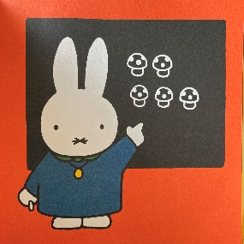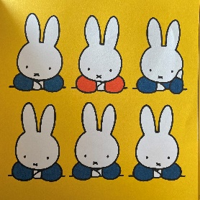  Miffy at school and teacher in front of the class | Symbol for Bauhaus
Free time
When humanity became grudgingly aware of all the misery of the First World War, the international desire to make a fresh start grew. That also happened in art. Bauhaus was founded in 1919 in the Weimar Republic, an education for visual artists, craftsmen, and architects. Johannes Itten developed a Vorlehre for this training. He first let students get rid of all their biases and all their conceptions about art. Itten stated that they first had to 'discover' colours, shapes, and materials before they could produce new creative ideas themselves.
Our word 'school' is derived from the ancient Greek word scholé (Masschelein & Simons, 2011). And that means 'free time'. That will sound strange to children. Most importantly, for children, free time is the time that they do not have to go to school. Until now, it is not so strange to strive for more 'free time' at school. School time is not just for the government, the economy, the church, or the parents. This is called the social importance of education. But school time is also time for the child itself! This concerns time at school that children can use themselves, in which every child is given the opportunity to discover and develop themselves as a person, to learn to make choices, to discover their own preferences and interests and to develop good talents. And that requires 'free time', time to try and experiment, to make mistakes and to learn from them. This idea is referred to as the personal interest of the school. This includes the right to make mistakes, to fail and to discover that something is not for you.
The school as a handyman of society
“Children represent the possibility of a new beginning,” says Daan Roovers (2019), referring to Arendts. She sees that as something hopeful. In this way the world can be 'born again'. That optimism is the reason modern society expects a lot from education.
Education therefore has a social importance. The school introduces new generations into the existing culture. The school has the task of equipping new generations with knowledge, skills, and attitudes in such a way that they can smoothly enter society and participate. In this way that society is maintained, and it is reproduced, as it were. At the same time, it is also the intention that education equips a new generation to shape the renewal of that society. Ultimately, society is not static but evolving and that requires upbringing and education to actively participate and to be able to contribute to social changes. In this way, education contributes to the preservation of culture and to progress and innovation, to helping to build a living democracy. In that sense, the school has been called the foundation of society.
In equipping children for society, the school is often overstretched. In this context, Biesta (2019) rightly asks whether the school should be seen as the handyman of society. He answers that question in the negative. Society questions the school. The school is not an instrument for tackling and solving an entire range of social problems. Problems such as poverty, discrimination, war, housing shortage, unemployment and growing up in a language-poor environment cannot be solved by the school. Education is not 'the great equalizer' (Van der Zee, 2021), but it is often positioned as such. And that is dangerous. The wish list of society can become so large and thus the pressure on teachers can be increased to such an extent that education is less and less able to fulfil its primary task: to equip children in such a way that they can flow into society.
The pressure on teachers to be of great significance in a social sense does not only come from society itself. Even teachers themselves have ideas for this. It is even an important aspect of their ideas among the various reform pedagogues. Maria Montessori, for example, gives one of her books the title Through the child to a new world. She has an optimistic view that education can help build a peaceful world. Peter Petersen describes the child as a cultural participant, but also as a cultural innovator. And he too has the ideal that children in school can learn to renew the culture and improve the world. Something similar can also be seen at Parkhurst. She believes that children should be prepared and equipped to make responsible choices and to solve social and political problems in the world.
The idea that education also exerts influence on society is sometimes referred to as the school's own interest. As a social institution, the school is an independent part of that society and is therefore partly owner of itself and involved and entitled to help shape the direction in which society is renewing.
In addition to that social interest and its own interest, the school also must consider the personal interest in the child's school. In education, children must be provided with time, space, and an offer to develop into an independent person.
Therefore, the school is not just a handyman of society. Too many social claims do not do justice to the autonomous mission of that education (Schuyt, 2001). The school is of course a supplier to society, but at the same time it is itself part of that society. As a social institution, it has a voice in the society as well. In addition, the school has the task of teaching children to develop into a person who wants to be. Consequently, that personal interest in the school of children is also in danger of being lost. The (Dalton) school therefore has the task of resisting extreme or undesirable demands made by the government or the economy regarding, for example, the content of the curriculum, the time spent at school or the didactic-organizational methods.
The social interest and the personal interest of the school conflict in a certain sense. You can ask the question which school society needs, but also the question which society needs the school. The first question is legitimate. Society may, of course, examine from time to time whether the school (the education system) still meets societal expectations. That question concerns whether the school is worth the annual investment. That money should pay off. Most importantly, the school is expected to be a productive space, a powerful learning environment, where children learn socially important knowledge and skills. From this point of view, 'good' education is defined as education that adapts to the wishes of society and in which children are adapted to those wishes.
Simultaneously, the school also has the task of resisting what is going on in society (Meirieu, 2007). Social developments should be critically questioned, and children should be helped to participate in that critical questioning.
Moreover, what Beckett once said about the school is true: “School is where we try, fail, try again, and fail better” (Gecit in Biesta, 2020).
The personal importance of education means that the school should be a training place and therefore not a productive space. That is where the school is still 'scholé', where there is time that does not immediately need to be productive and functional, which society has not yet seized, and which is not yet overloaded with all kinds of expectations. The school is not a 'powerful learning environment' there. Then the school is a continuation of the spirit of Van Houten's 'child law' (1874), which allowed children to go to school and thereby freed them from the need to work. That law was intended to literally give children school time (Biesta, 2020).
And that also makes the question whether we still have a society that still gives the school room for 'scholé', where not every hour is devoted to achieving goals and achieving learning efficiency. In this context, Biesta (2020) speaks of the 'learnification of education'. Children are only perceived as pupils, schools only as learning environments. And teaching time has increasingly become a means of production of human capital. And that comes at the expense of the formative value of the school.
The function of education
In addition to being aware of the importance of education, it is also advisable to distinguish distinct functions. Much has been written about this, but nowadays there is quite a lot of talk about 'the three of Biesta': qualification, socialization, and subjectification. These are three interrelated domains that form the essence of what education is all about. They offer a broader view of education.
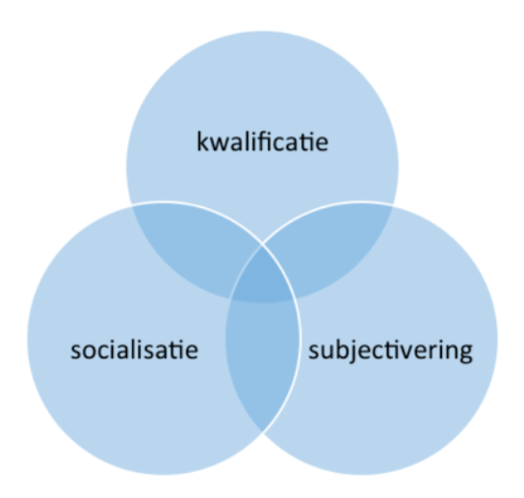
The functions of education (Biesta, 2012)
Qualification is about the care that education takes to allow pupils to acquire (general) knowledge, skills, and attitudes, so that they can function in society. Qualification therefore has to do with competence.
Socialization is about students adopting specific norms and values, behaviours, and attitudes, on which the democratic society is based and in which they propagate them. This also includes that the students build up an image of themselves and work on identity formation. Socialization ensures that children become part of social, societal, and cultural systems. Socialization has to do with social connection.
Subjectification focuses on arousing an intrinsic desire to live your life in a mature way. This is about wanting to be an independent person, about autonomous and independent thinking and acting, with the moral dimension of wanting to do the right thing. It is about teaching children to weigh up as adults: Is what I wish desirable for me and my life with the other and the other? (May, 2015).
There is a tension in finding a balance between these three target domains. This tension manifests itself in an abstract sense, but also at the level of concrete educational practice.
‘Stuck in the system’
The education system as we know it today was developed through systemic and economic thinking. It is unlikely that an educational pedagogue or psychologist would give thirty children of the same age the same time to acquire the same subject matter and to present it in the same way. After all, in the curriculum year class system, children are grouped into year classes, the subject matter is ordered in proportions of a year, and we guide the children in year classes through those learning material packages in the same way and at the same time. With a few exceptions, all school buildings are built for this system as well: with a separate room for each year class or a combination of year classes.
This curriculum year class system has become so prevalent that many individuals have come to take it for granted. But to break free from 'preconceived conceptions' about the school, we must realize that they are all agreements. There is no pedagogical law, no educational evidence or psychological necessity that education ought to be be organized in this way.
An example makes clear what this means. In the Netherlands, children in group 3 learn to read at the age of 6 to 7, but there are also countries where they do so earlier and countries where they do so later.
In this context, the concept of 'educational disadvantage' also takes on a different dimension. It is not that there is a denial of their existence, nor is it the case that we should not strive for equal opportunities for children, but disadvantages are always about lagging compared to previously relatively arbitrary agreements that are now current system apply. Are we talking about a disadvantage compared to the average child (which does not exist by the way), compared to the school norm, compared to what is asked in the tests, compared to the lessons from the methods, i.e. compared to what method developers have thought of what a curriculum structure per grade could look like in order to achieve the core objectives? (Berends, 2021). It makes clear that in a sense we are stuck with the question of whether the child is there for the system, or the school system is there for the children!
It is recognized across the entire spectrum of the educational field that the curriculum year class system is not ideal, but it is there. Changing that while on the road is a heathen job. We are stuck in what is called the 'grammar of schooling' and within which the 'lockstep teaching' cannot be fundamentally changed (Van der Ploeg, 2013).
In this regard, Ken Robinson points to the need for a 'paradigm shift'. The film in which he explains this is the most watched film about education on YouTube. But our awareness that education requires a systemic change does not mean that it will happen soon. The train rumbles on quietly. This wish was already widely shared among reform pedagogues. In their critique of the curriculum year class system, they pointed out that no justice is done to the uniqueness of each child and to the differences that exist between children regarding developmental stage, interest, learning ability, pace, and level.
The school as a (moral) community
If the school is seen as a broader educational institution where more is done than just qualifying children, it is necessary for socialization and for personal development – ​​after all, for which others and the world are also needed – to pay attention to the school as a (moral) community. And that morality is about norms and values. You could say that standards are the rules, the practical guideline for realizing values.
The classroom and school provide a safe practice space for this. The classroom and the school are, as it were, a mini society with a democratic and participatory character. There children can practice through trial and error what it is like to live together with others. Similarly, the school as a community is also a vehicle for value transfer, a powerful moral learning space, in which children learn to set rules, abide by them, learn manners, and discover that in a moral community, boundaries are also guarded, and rules enforced.
The environment of the school
The world is my classroom (Freinet).

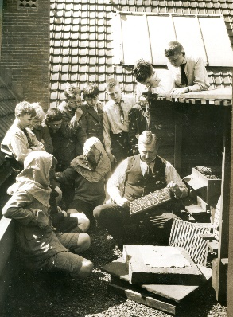 | 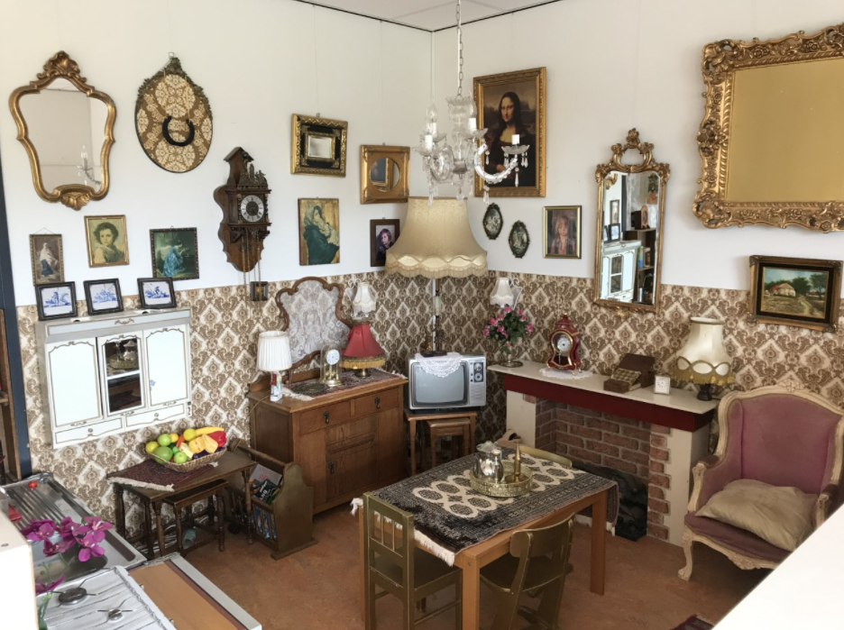
Lesson about bees on the roof of the C. Vrijschool in Amsterdam, 1924 | A home corner furnished with authentic materials
For broad personal education where children learn to relate to themselves, the other and the world, the environment of the school and the living environment of the children is also important. You can enter the outside world with the school to allow children to gain lifelike experiences ('real life skills'). At the time, Theo Thijssen went for a walk with his children in the Vondelpark and did not teach there from a book about nature, but outside in nature. Marten Vrij, one of the first Daltonians in the Netherlands, kept bees on the roof of the Cornelis Vrijschool and took the children onto the roof of the school.
Similar is the story of Célistin Freinet. He discovered that his children liked learning, but not school. Therefore, he took them outside.
A prepared environment in the classroom
The world can also be brought into the school from the point of view of providing broad personal education. Setting up a prepared environment in the classroom or in the school should be carefully considered. What are the goals? Which themes or projects are at play? What can be used at which stage of the children's development?
Children can also be involved in the design of the school, the classroom or even a themed corner. This is even recommended from the Daltonian idea of ​​making children more owner of education for their own learning. Of course, having control over and bearing responsibility for the environment includes not only the design, but also the joint maintenance and care of that environment. Most Dalton teachers use a system for this in which children are responsible for a large part of taking care of the classrooms and spaces.
Building blocks for a vision of the school
In this section, attention has been paid to the desirability of nurture your educational vision to the building block of the school as a social education institute. It has been made clear that the school as well as the school environment, the neighbourhood, the village and even the own city where the child lives has formative value that can be used in the offer at school. Appendix 5 formulates questions that can be used to arrive at such a vision.
The excellent Dalton teacher and Dalton school
In this article we have said that Dalton is about 'doing the best in the best way'. And our Dalton vision helps us to define what is 'the best' to do.
In the Netherlands, the Dutch Dalton Association (NDV) guarantees the quality of Dalton education by having expert and experienced colleagues from its own ranks visit Dalton schools as 'critical friends'. And during these visits, schools are asked to explain their Dalton vision, after which the visitators investigate whether that Dalton vision is also being realized in practice.
Schools therefore determine, to a certain extent, what is best for them to achieve in their Dalton education. During their visit, the visitors reflect on whether they also see this vision reflected in practice.
As a result of this practice, research has been conducted into the effects of this assessment. In addition, research has been conducted into what constitutes a good or excellent Dalton school. It was agreed that it is important to realize the own Dalton vision effectively and efficiently.
The research shows that the compulsory self-evaluation of the schools during the assessment and the assessment procedure followed promote the quality of Dalton education in the schools. It encourages development and stimulates the improvement and development of Dalton education (Sins, Groenewoud & Otten-Binnerts, 2017).
The success of the assessments was preceded by a process in which visitors were trained in assessments. They have also jointly developed indicators to objectify Dalton's degree. When the minimum quality indicators that Dalton schools must meet to obtain the license had been formulated, the follow-up question arose as to what a Dalton school could do to excel. Visitors indicated that it is possible to 'feel' when a school 'breathes Dalton', but that the factors responsible for this are difficult to describe (Otten-Binnerts & Sins, 2019).
A follow-up study attempted to objectify these factors by asking Dalton experts and visitors how to measure Dalton quality and which characteristics show that a Dalton school excels.
Five characteristics of excellent Dalton schools emerged from this research (Otten-Binnerts & Sins, 2021):
- A clear shared vision with a clear structure and coherence of the Dalton core values
An excellent Dalton school is distinguished by the fact that a sharp vision of Dalton education is applied at all levels of the school and a clear continuous Dalton line is visible. The through line is fully developed and constructed in a responsible manner; there are no gaps. The core values ​​are reflected in the attitude of both students and teachers. It is therefore not a question of an outward form of Dalton, as can be expressed in materials and means. It is about the way in which materials and resources are used and for what purpose.
There is a shared and supported vision with a clear structure of all core values. The core values ​​are the organizational forms, and they are linked to each other. They form the basis and are integrated and interwoven throughout the school organisation. It is therefore not separately on the schedule, such as a collaboration or reflection moment. The core values ​​are conditional, so that children start thinking, planning, setting goals and reflecting for themselves. It is about trying to think from the point of view of the child – how does the child pick up the work? – to then go in depth with the child. The point is that skills are taught in a conscious way, based on a continuous and constructive learning line within the school.

- Visible Dalton development and reflection on this development
An excellent Dalton school is characterized by permanent development. There is room for development and there are clear plans to map out and further expand Dalton development. This development is not only visible in practice, but it is continuously reflected on, at the child, teacher, and school level. Reflection therefore plays a key role. Reflections lead to new goals and subsequently to the initiation of new developments that lead to improvements.
A good Dalton school is goal oriented. There is uniformity and work are predictable. This makes it clear to children when which instruction is given. Only when that is clear can they schedule their work themselves in time. Tasks are performed based on goals to be achieved. It is important to explicitly teach and develop the skills that children need for this. Teachers are focused on the personal development of the children and from this attention to personal development they achieve results.

- Professional attitude and culture and ownership of all involved
Ownership means that children and teachers are owners and are made of their own learning process. This is done by collaborating with each other daily. In this way, according to the visitors, you create a 'Dalton consciousness'. According to visitors, it is more important that as a school you radiate and live that 'Dalton consciousness'. To do this, it is necessary to know what a Dalton school is and how it works and that there is communication about it and that you also radiate that together. It is about awareness of teachers and students and preferably also of parents.
The role of the teacher is important here. In the first instance, he must be 'dalton-minded'. This means that he or she remains aware of his or her added value. It is about the why: Why am I doing things? Am I doing the 'right' things and am I doing the things 'right'? So, ownership. Teachers must have these themselves, but also offer them to their students. It requires an open attitude from those involved in the assessment visit, daring to give responsibility to students, self-evident collegiate consultations and daring to indicate what is going well and what still needs to be worked on. Such an open and positive attitude should also be reflected in the students. The teacher is the coach, who coordinates with the children what is necessary to develop. His basic question is: “What do you need to achieve that goal?” Visitors indicate that this demands a lot from the development of the child and the teacher. For example, how do you as a teacher keep an overview? Such a professional attitude and culture requires commitment from the teacher, the team, and the management. The management and the Dalton coordinator or the Dalton working group are important and inspiring. The excellent Dalton school is characterized by a positive atmosphere, which can be seen and read both at the school and in the documents supplied by the school. Visitors read the documents and hear little or no 'yes-buts' during the visitation.

- Society in the school
Dalton education focuses on what children need in society. The personal development and personality formation of the child is central to this. The point is that children are given tools to be able to work (together) to absorb the material, that children can name what they are good at and what they still must learn. All this in a safe setting. The point is that children experience that it is normal for differences to exist and that they learn how to deal with them and that there is a sense of community in which children can learn from and with each other. The point is that in education space is given to things from everyday life. The school reflects what children need in society.

- Stability in the composition of the team
According to visitors, Dalton quality stands or falls with the team. An excellent Dalton school cannot do without a stable team of teachers. According to visitors, schools run into problems when there are changes within the team and management. When there are outages or changes, it is more difficult to guarantee continuity and there is a risk of gaps and gaps. Substitutes cannot pick up everything at once and go along with the developments at school. They must first have followed a Dalton education to be able to carry out Dalton education properly. With the current development in education (including the teacher shortage), there are major concerns about guaranteeing continuity at Dalton schools. According to visitors, the Dalton level also decreases if teachers and directors have ended up at a Dalton school 'by chance' and not because of ambition or a vision.
Developing your own professional identity
To keep the course as a Dalton school and persistently do 'the right' in a 'right' way, it is important that the team finds and stays in balance together. This requires team members who also find and remain in balance as individuals. This requires that teachers work on their professional identity and that they know what the intention is and try to act on that intention together.
It does not seem all that difficult to the outside world to take children from A to B. But with such a mechanistic professional image, teachers are discredited, and the subject is not properly valued.
We have seen that practice is unruly, that there are numerous interests at play in education, that the school has distinct functions, that situations and circumstances vary from moment to moment and that all those children are different from each other. All these varied factors make education complex, multidimensional, whereby teachers must be given the space and time to judge what 'doing well' means.
The artisanship of the teacher obviously requires knowledge and a set of skills. But a professional identity goes further. That is also about having a feeling for children and about meaning something in the world, but above all about the importance and power of the teacher as a person. All those aspects of teaching are necessary to solve the puzzle that teachers are faced with how to teach growing children to relate to themselves, the other and the world.
Biesta (2017) indicates that teachers have a lot to offer. If they have an unobstructed vision of what it is all about, the 'how' will come naturally. It is important to be together, to collaborate with each other, to talk, to learn and to experiment.

In this article five building blocks are provided to develop your own educational pedagogical vision. It has been described how such a vision develops from a subjective concept of a beginning student to a richly varied professional identity of experienced teachers. Such an identity develops as teachers’ study, experiment and reflect on their practice together. For a Dalton teacher it is important to become acquainted with the principles of Dalton education and to (learn to) relate to those principles, but also to the criticism that is expressed on them. 'The' Dalton view does not exist, but that does not mean that teachers do not work from a Dalton view. They are expected to develop their own Dalton vision in consultation with other Dalton colleagues and to be inspired by the ideas of Parkhurst.
Dalton is not a 'trick' that you perform between 8.30 am and 4.30 pm. It is in you. It is about a vision that you propagate and that you also live in tune with yourself. Then 'teach as you preach' applies. Then you can 'feel' Dalton but also 'see' it: in the way you deal with children, how you support and help children in their search, how you sit with children and work from your own passion, in how you anticipate, but also how you set an example, structure education and create contexts, radiate trust, allow and give children freedom, how you take them into account and account for yourself, how you stimulate children, have conversations with them and how you work, learn an live with the children.

This article is based on chapter 2 from the Dutch training book for Dalton education: Berends, R., van Slochteren, H.M. & Otten-Binnerts, V. (2021). Dalton: LEF. Deventer: Saxion Progressieve Education University Press.

